University of Tartu

Faculty of Mathematics and Computer Science

System Modelling

Mancala Project

Storyboards

Authors: Simo Peterson

Mart Sein

Margus Sellin

Raigo Kodasmaa

Coordinator: Dmitri Danilov

Tartu, 2011

**Version Control**

|  |  |  |  |
| --- | --- | --- | --- |
| **Date** | **Changes** | **Comments** | **Author** |
| 10.11 | Storyboards. | User story with object diagrams. | Raigo |
| 13.11 | Storyboards. | Refactoring the structure of the document. | Simo |

Table of Contents

Storyboards 4

# Storyboards

1.

Title: Bob makes a move from pit 1

Preconditions: the pits on the board contain the following amount of counters: pit 1 – 4, pit

2 – 4, pit 3 – 4, pit 4 – 4, pit 5 – 4, pit 6 – 4, pit 7 – 4, pit 8 – 4, pit 9 – 4, pit 10 – 4, pit 11 – 4, pit 12– 4. There are 0 counters in Bob’s big pit and 0 counters in Alice’s big pit.

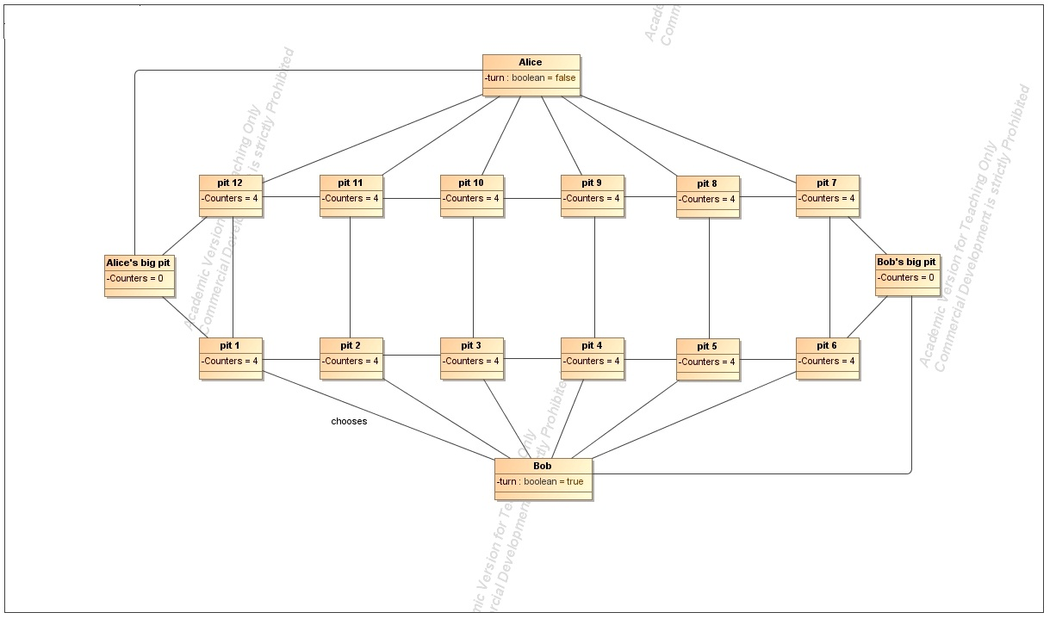

Postconditions: the pits on the board contain the following amount of counters: pit 1 – 0, pit

2 – 5, pit 3 – 5, pit 4 – 5, pit 5 – 5, pit 6 – 4, pit 7 – 4, pit 8 – 4, pit 9 – 4, pit 10 – 4, pit 11 – 4, pit 12– 4. There are 0 counters in Bob’s big pit and 0 counters in Alice’s big pit.

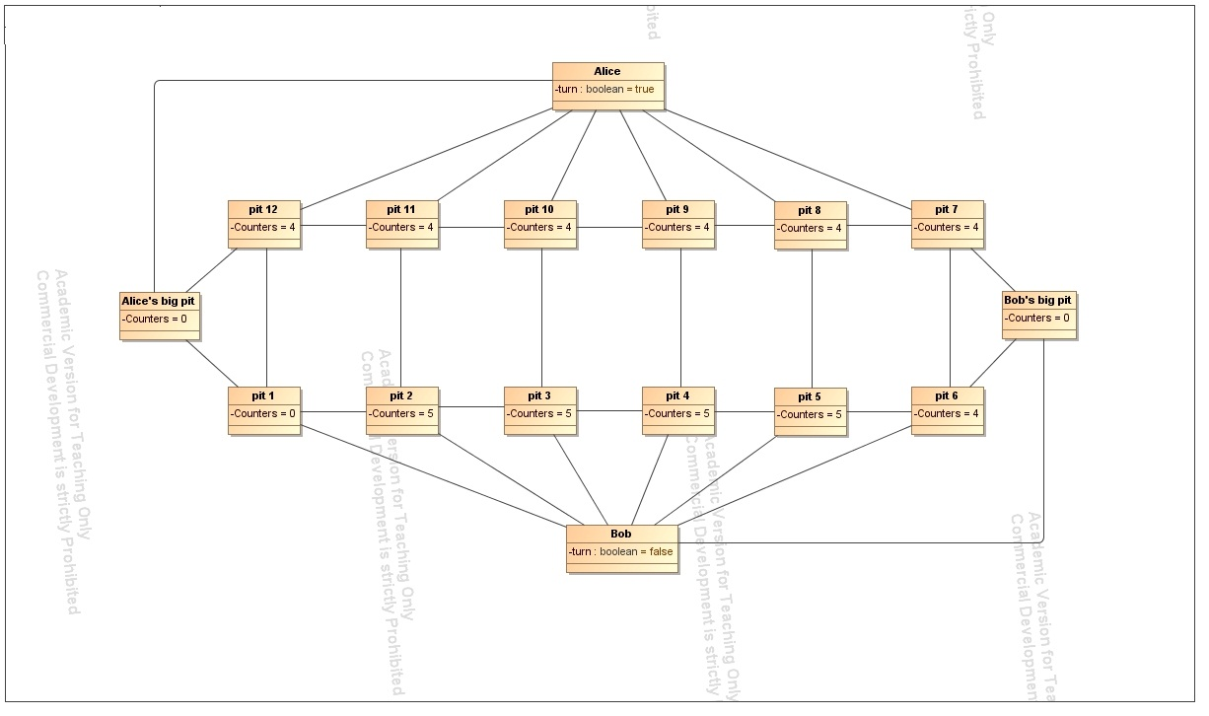

2.

Title: Alice makes a move from pit 7

Preconditions: the pits on the board contain the following amount of counters: pit 1 – 0, pit

2 – 5, pit 3 – 5, pit 4 – 5, pit 5 – 5, pit 6 – 4, pit 7 – 4, pit 8 – 4, pit 9 – 4, pit 10 – 4, pit 11 – 4, pit 12– 4. There are 0 counters in Bob’s big pit and 0 counters in Alice’s big pit.

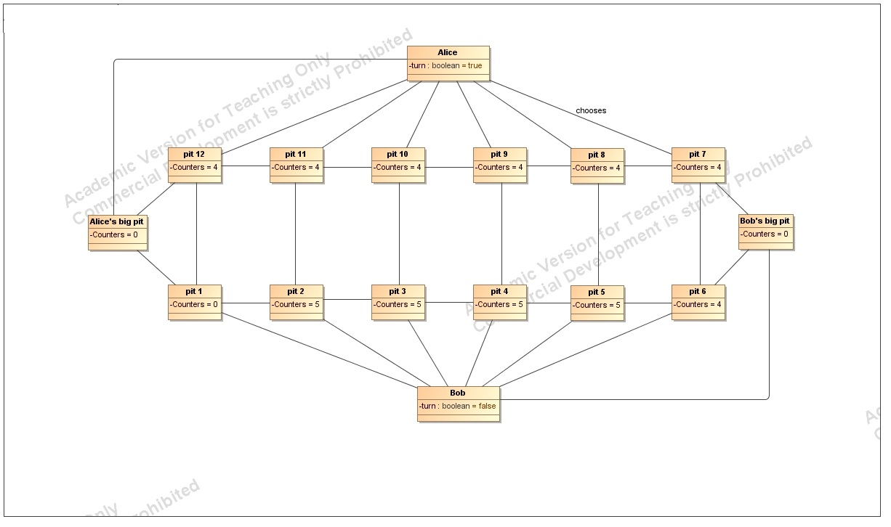

Postconditions: the pits on the board contain the following amount of counters: pit 1 – 0, pit

2 – 5, pit 3 – 5, pit 4 – 5, pit 5 – 5, pit 6 – 4, pit 7 – 0, pit 8 – 5, pit 9 – 5, pit 10 – 5, pit 11 – 5, pit 12– 4. There are 0 counters in Bob’s big pit and 0 counters in Alice’s big pit.

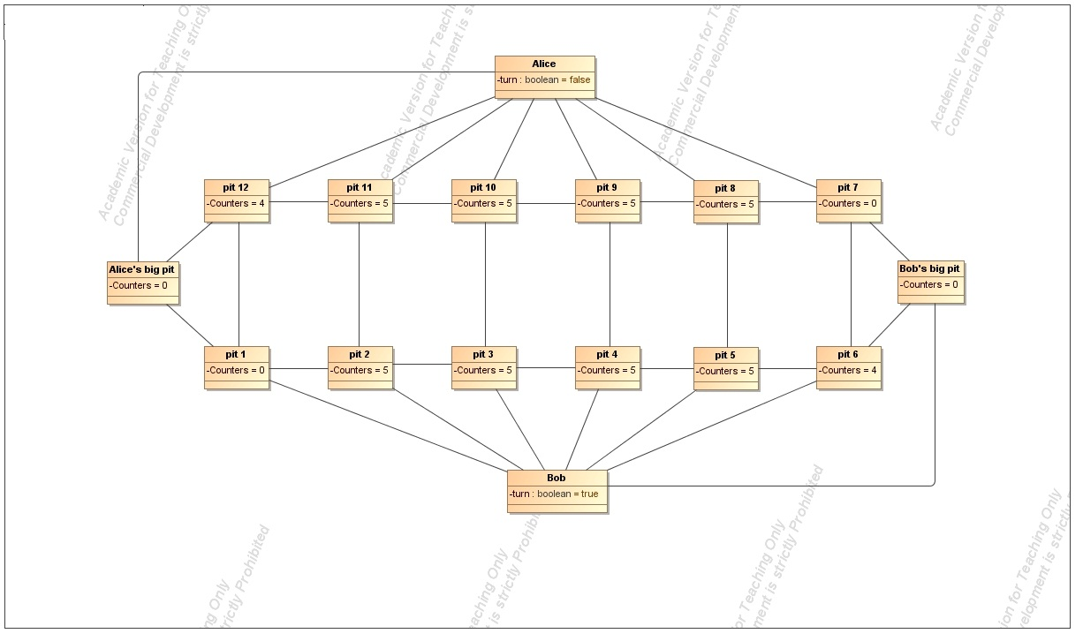

3.

Title: Bob makes a move from pit 2

Preconditions: the pits on the board contain the following amount of counters: pit 1 – 0, pit

2 – 5, pit 3 – 5, pit 4 – 5, pit 5 – 5, pit 6 – 4, pit 7 – 0, pit 8 – 5, pit 9 – 5, pit 10 – 5, pit 11 – 5, pit 12– 4. There are 0 counters in Bob’s big pit and 0 counters in Alice’s big pit.

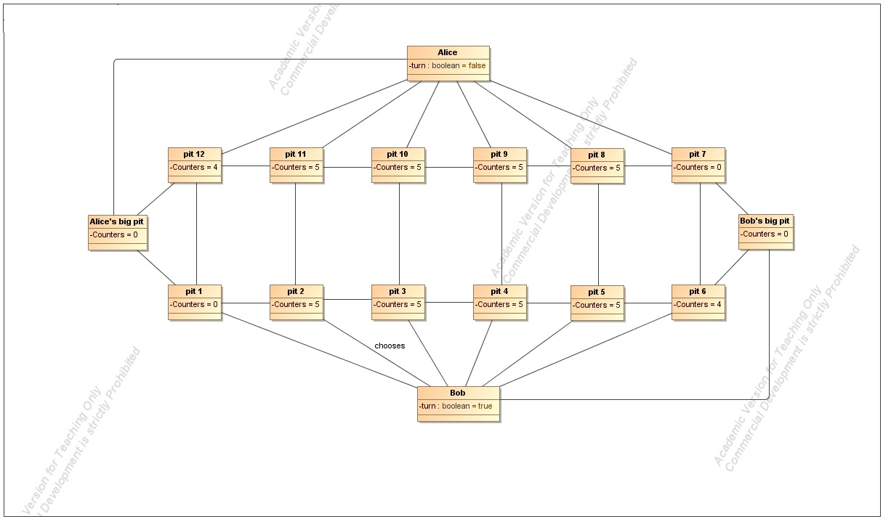

Postconditions: the pits on the board contain the following amount of counters: pit 1 – 0, pit

2 – 0, pit 3 – 6, pit 4 – 6, pit 5 – 6, pit 6 – 5, pit 7 – 0, pit 8 – 5, pit 9 – 5, pit 10 – 5, pit 11 – 5, pit 12– 4. There is 1 counter in Bob’s big pit and 0 counters in Alice’s big pit. Bob gets and additional move.

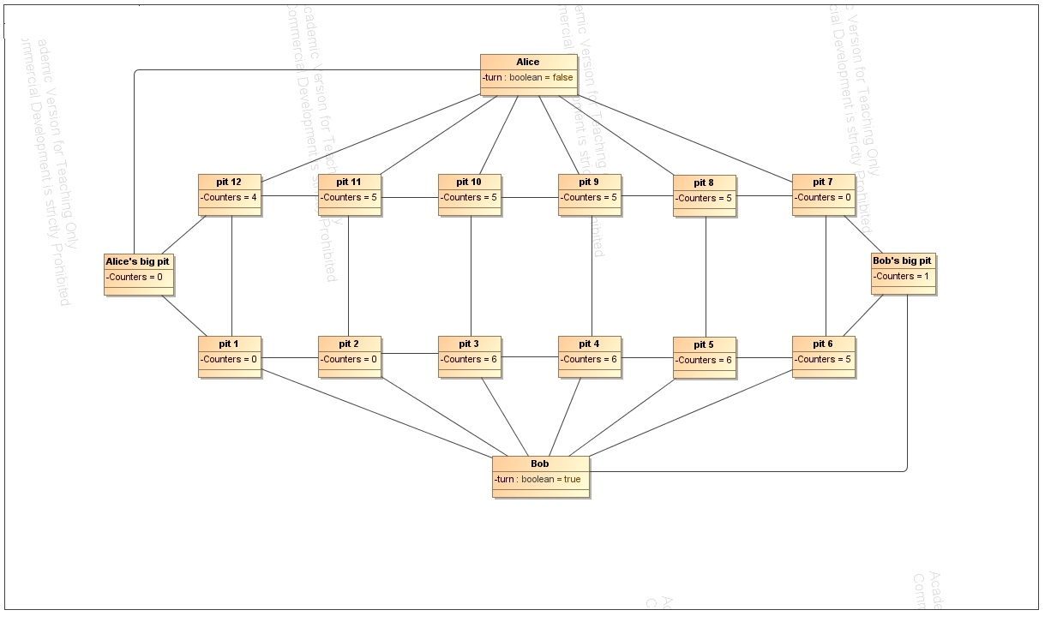

4.

Title: Bob makes a move from pit 3

Preconditions: the pits on the board contain the following amount of counters: pit 1 – 0, pit

2 – 0, pit 3 – 6, pit 4 – 6, pit 5 – 6, pit 6 – 5, pit 7 – 0, pit 8 – 5, pit 9 – 5, pit 10 – 5, pit 11 – 5, pit 12– 4. There is 1 counter in Bob’s big pit and 0 counters in Alice’s big pit.

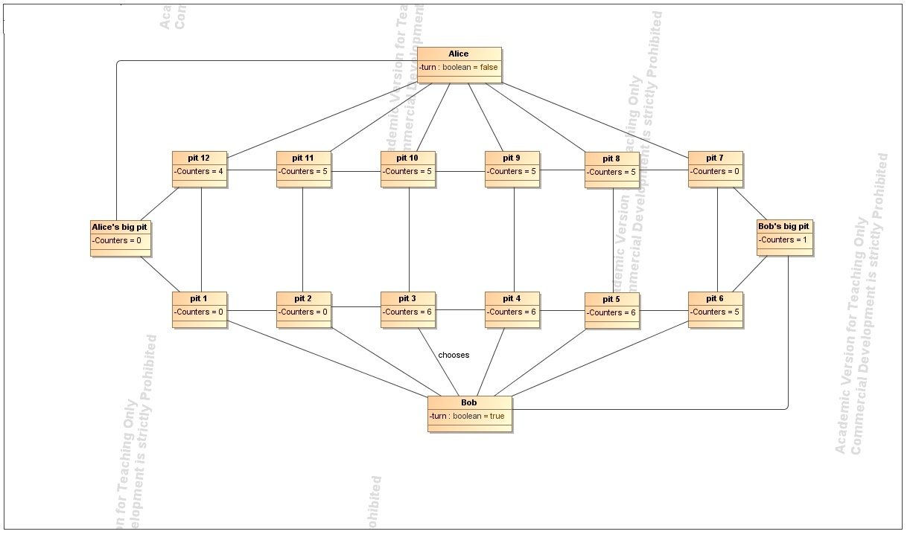

Postconditions: the pits on the board contain the following amount of counters: pit 1 – 0, pit

2 – 0, pit 3 – 0, pit 4 – 7, pit 5 – 7, pit 6 – 6, pit 7 – 1, pit 8 – 6, pit 9 – 5, pit 10 – 5, pit 11 – 5, pit 12– 4. There are 2 counters in Bob’s big pit and 0 counters in Alice’s big pit.

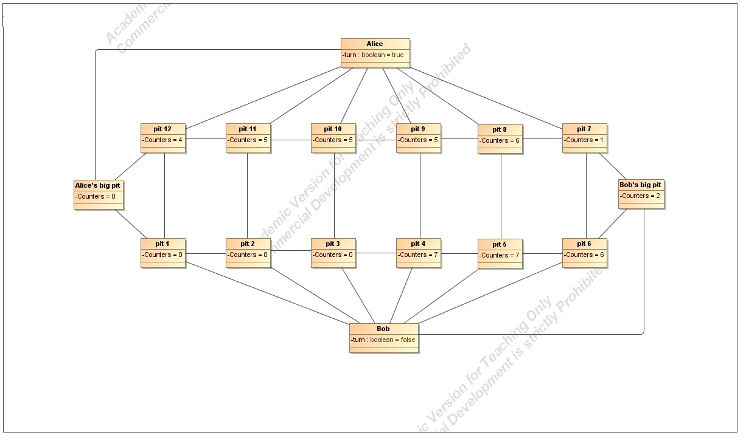

5.

Title: Alice makes a move from pit 7

Preconditions: the pits on the board contain the following amount of counters: pit 1 – 0, pit

2 – 0, pit 3 – 0, pit 4 – 7, pit 5 – 7, pit 6 – 6, pit 7 – 1, pit 8 – 6, pit 9 – 5, pit 10 – 5, pit 11 – 5, pit 12– 4. There are 2 counters in Bob’s big pit and 0 counters in Alice’s big pit.

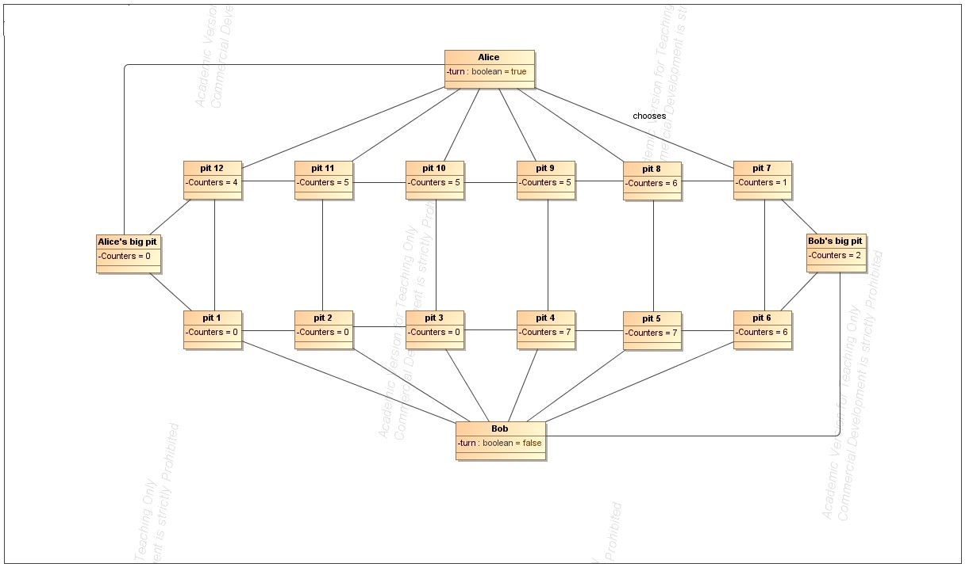

Postconditions: the pits on the board contain the following amount of counters: pit 1 – 0, pit

2 – 0, pit 3 – 0, pit 4 – 7, pit 5 – 7, pit 6 – 6, pit 7 – 0, pit 8 – 7, pit 9 – 5, pit 10 – 5, pit 11 – 5, pit 12– 4. There are 2 counters in Bob’s big pit and 0 counters in Alice’s big pit.

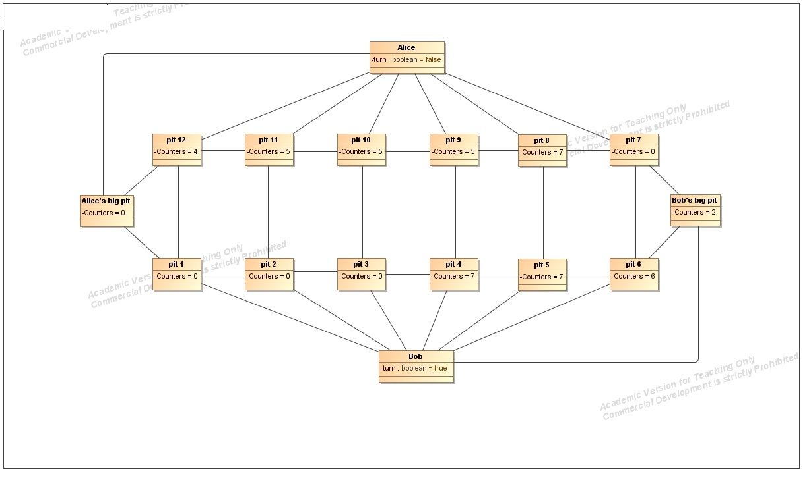

6.

Title: Bob makes a move from pit 4

Preconditions: the pits on the board contain the following amount of counters: pit 1 – 0, pit

2 – 0, pit 3 – 0, pit 4 – 7, pit 5 – 7, pit 6 – 6, pit 7 – 0, pit 8 – 7, pit 9 – 5, pit 10 – 5, pit 11 – 5, pit 12– 4. There are 2 counters in Bob’s big pit and 0 counters in Alice’s big pit.

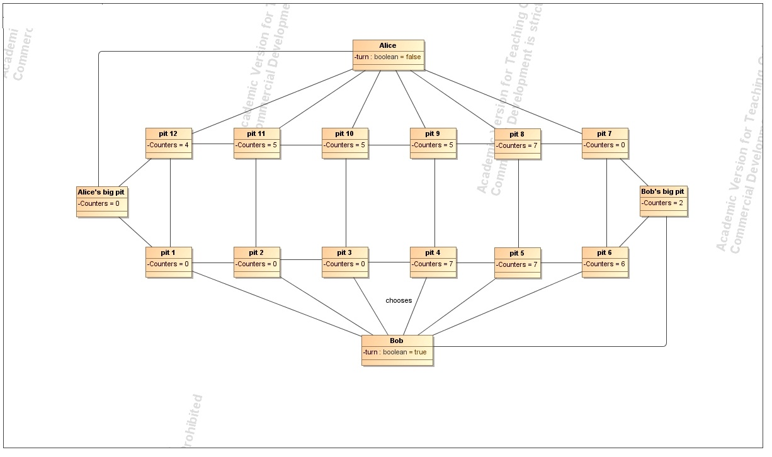

Postconditions: the pits on the board contain the following amount of counters: pit 1 – 0, pit

2 – 0, pit 3 – 0, pit 4 – 0, pit 5 – 8, pit 6 – 7, pit 7 – 1, pit 8 – 8, pit 9 – 6, pit 10 – 6, pit 11 – 5, pit 12– 4. There are 3 counters in Bob’s big pit and 0 counters in Alice’s big pit.

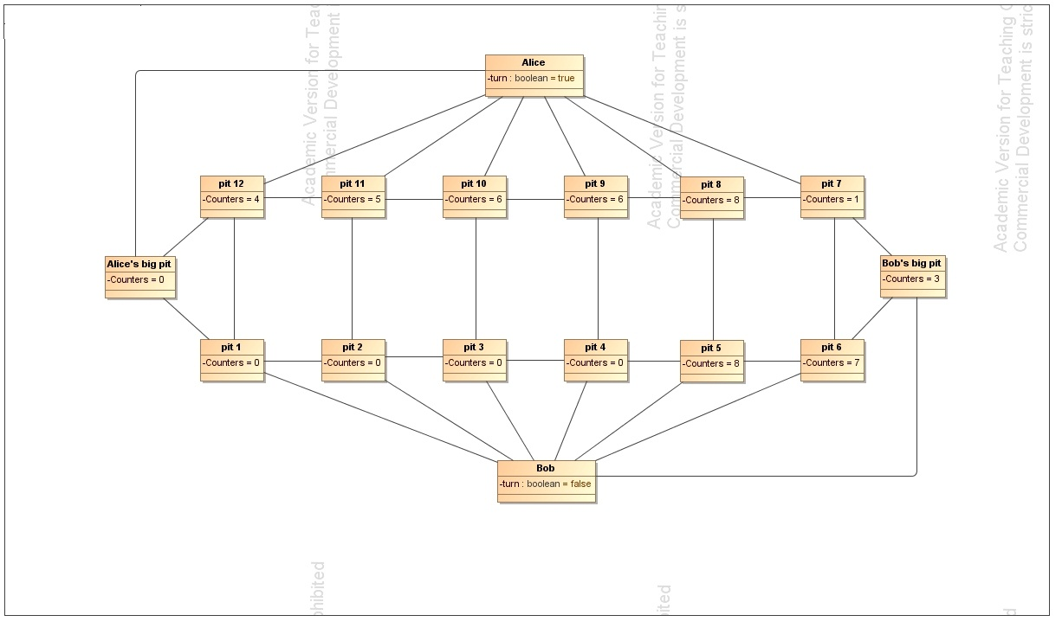

7.

Title: Alice makes a move from pit 10

Preconditions: the pits on the board contain the following amount of counters: pit 1 – 0, pit

2 – 0, pit 3 – 0, pit 4 – 0, pit 5 – 8, pit 6 – 7, pit 7 – 1, pit 8 – 8, pit 9 – 6, pit 10 – 6, pit 11 – 5, pit 12– 4. There are 3 counters in Bob’s big pit and 0 counters in Alice’s big pit.

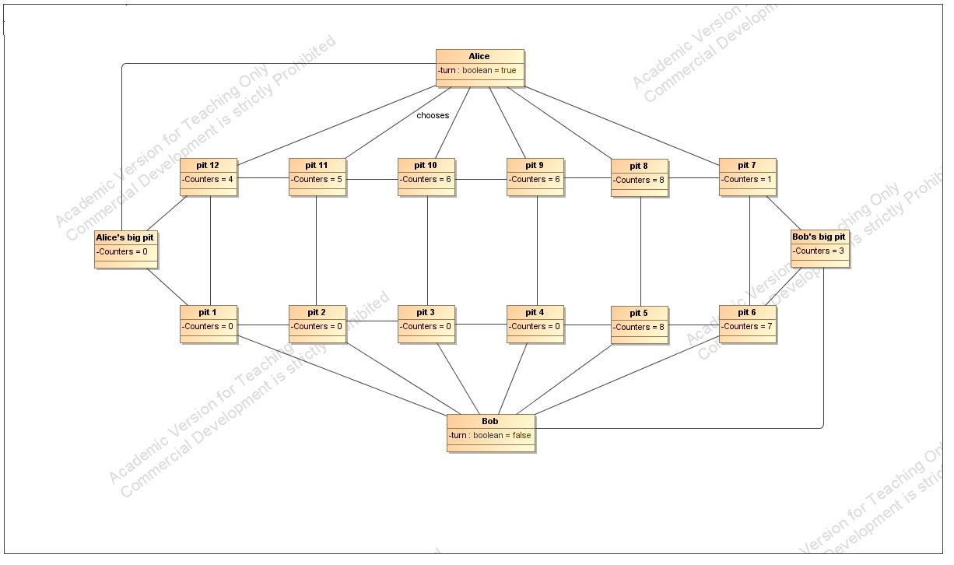

Postconditions: the pits on the board contain the following amount of counters: pit 1 – 1, pit

2 – 1, pit 3 – 1, pit 4 – 0, pit 5 – 8, pit 6 – 7, pit 7 – 1, pit 8 – 8, pit 9 – 6, pit 10 – 0, pit 11 – 6, pit 12– 5. There are 3 counters in Bob’s big pit and 1 counter in Alice’s big pit.

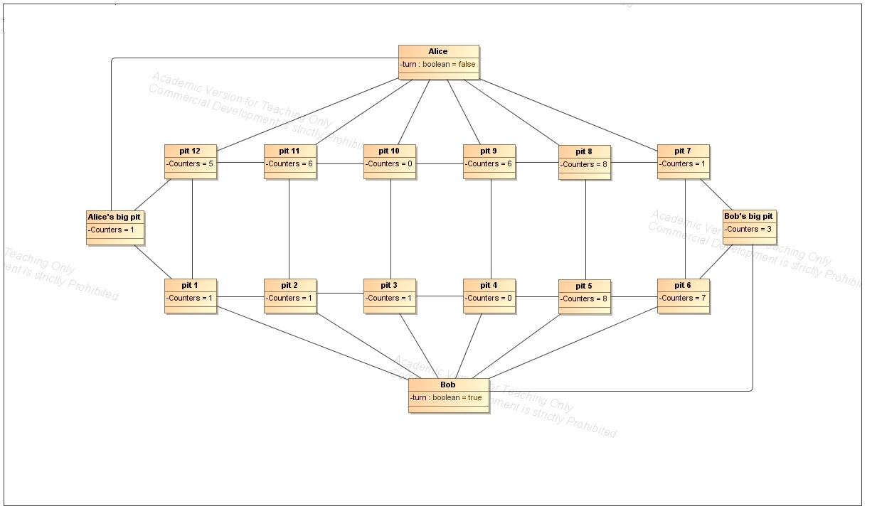

8.

Title: Bob makes a move from pit 6

Preconditions: the pits on the board contain the following amount of counters: pit 1 – 1, pit

2 – 1, pit 3 – 1, pit 4 – 0, pit 5 – 8, pit 6 – 7, pit 7 – 1, pit 8 – 8, pit 9 – 6, pit 10 – 0, pit 11 – 6, pit 12– 5. There are 3 counters in Bob’s big pit and 1 counter in Alice’s big pit.

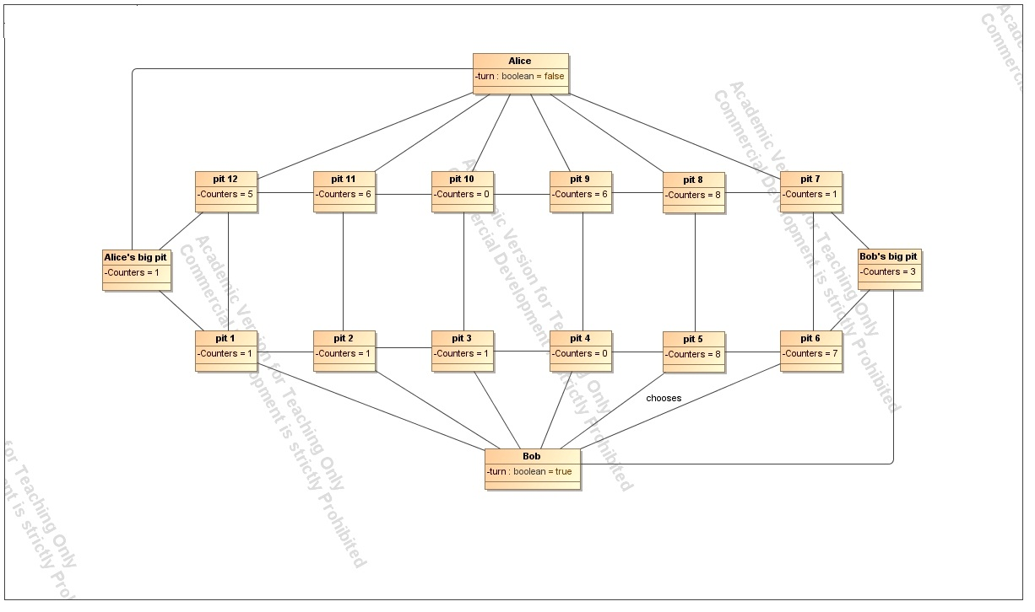

Postconditions: the pits on the board contain the following amount of counters: pit 1 – 1, pit

2 – 1, pit 3 – 1, pit 4 – 0, pit 5 – 8, pit 6 – 0, pit 7 – 2, pit 8 – 9, pit 9 – 7, pit 10 – 1, pit 11 – 7, pit 12– 6. There are 4 counters in Bob’s big pit and 1 counter in Alice’s big pit.

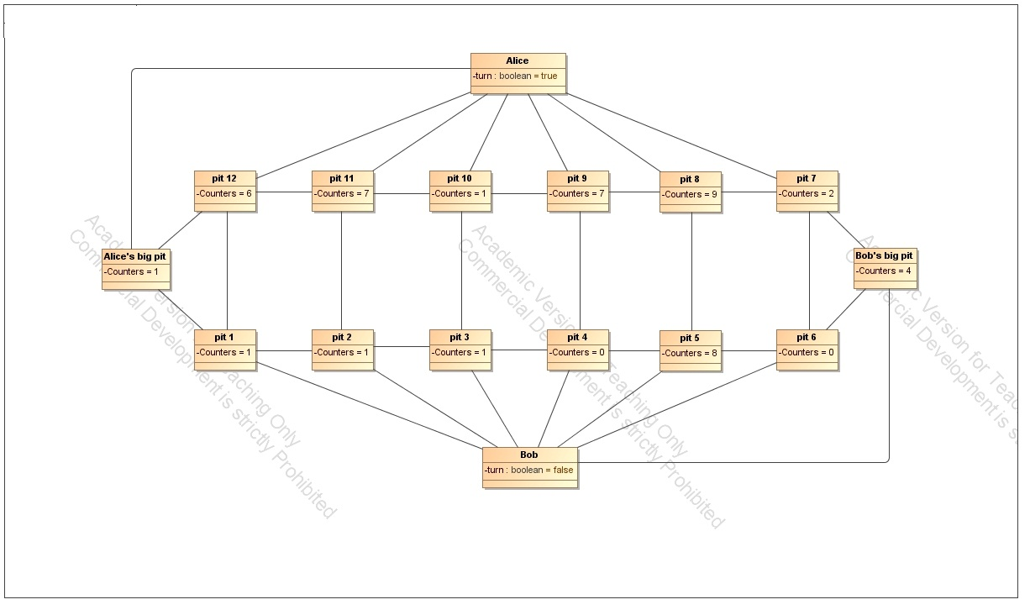

9.

Title: Alice makes a move from pit 7

Preconditions: the pits on the board contain the following amount of counters: pit 1 – 1, pit

2 – 1, pit 3 – 1, pit 4 – 0, pit 5 – 8, pit 6 – 0, pit 7 – 2, pit 8 – 9, pit 9 – 7, pit 10 – 1, pit 11 – 7, pit 12– 6. There are 4 counters in Bob’s big pit and 1 counter in Alice’s big pit.

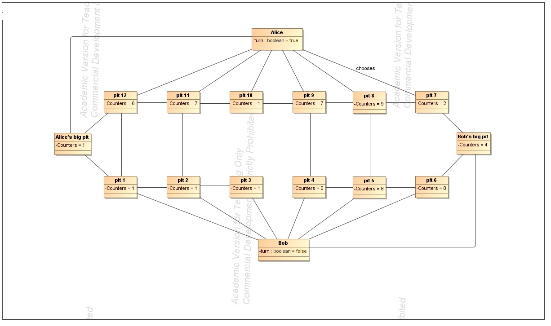

Postconditions: the pits on the board contain the following amount of counters: pit 1 – 1, pit

2 – 1, pit 3 – 1, pit 4 – 0, pit 5 – 8, pit 6 – 0, pit 7 – 0, pit 8 – 10, pit 9 – 8, pit 10 – 1, pit 11 – 7, pit 12– 6. There are 4 counters in Bob’s big pit and 1 counter in Alice’s big pit.

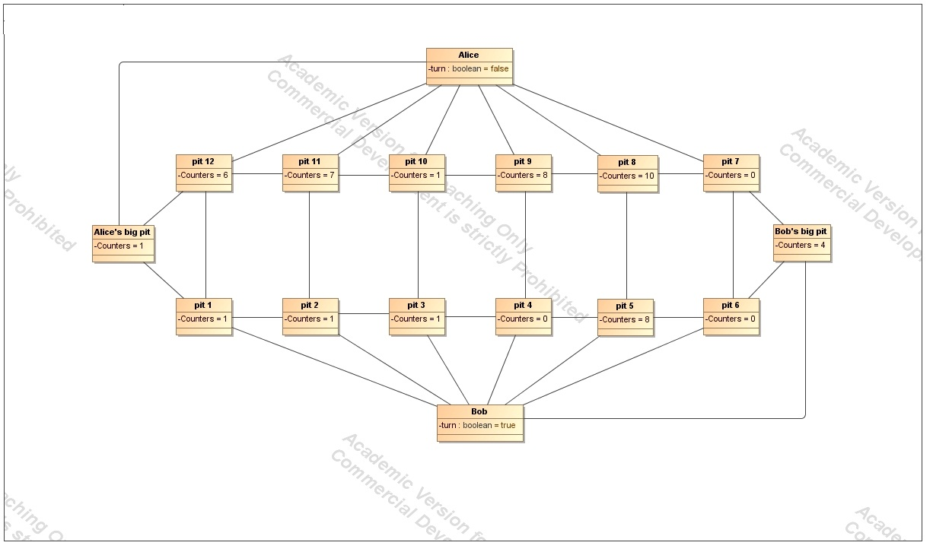

10.

Title: Bob makes a move from pit 5

Preconditions: the pits on the board contain the following amount of counters: pit 1 – 1, pit

2 – 1, pit 3 – 1, pit 4 – 0, pit 5 – 8, pit 6 – 0, pit 7 – 0, pit 8 – 10, pit 9 – 8, pit 10 – 1, pit 11 – 7, pit 12– 6. There are 4 counters in Bob’s big pit and 1 counter in Alice’s big pit.

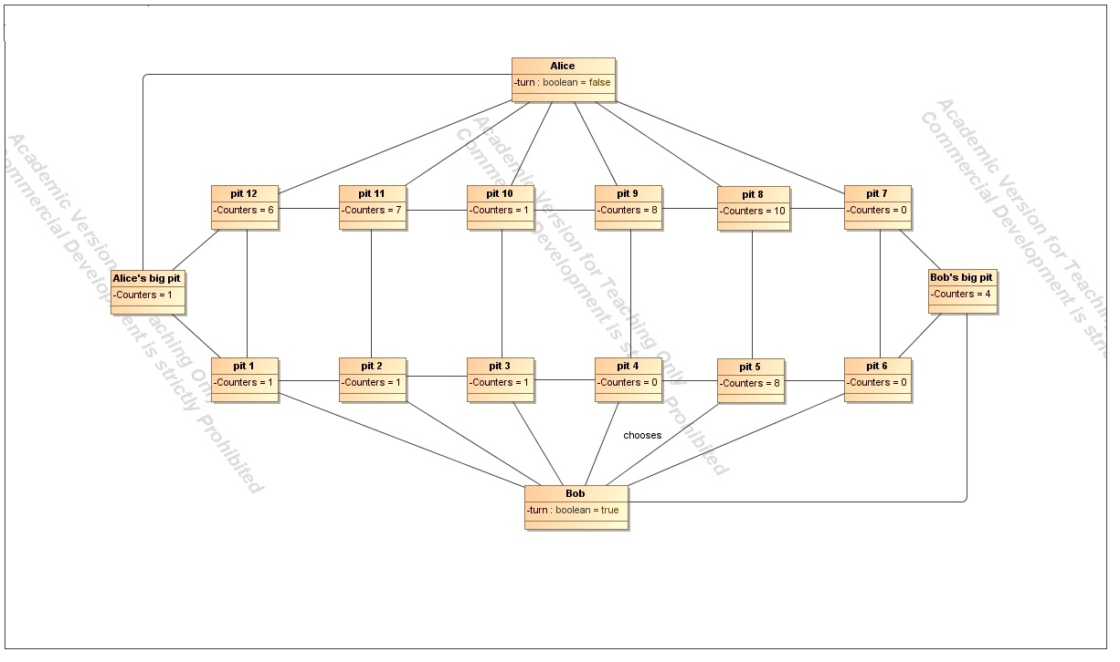

Postconditions: the pits on the board contain the following amount of counters: pit 1 – 1, pit

2 – 1, pit 3 – 1, pit 4 – 0, pit 5 – 0, pit 6 – 1, pit 7 – 1, pit 8 – 11, pit 9 – 9, pit 10 – 2, pit 11 – 8, pit 12– 7. There are 5 counters in Bob’s big pit and 1 counter in Alice’s big pit.

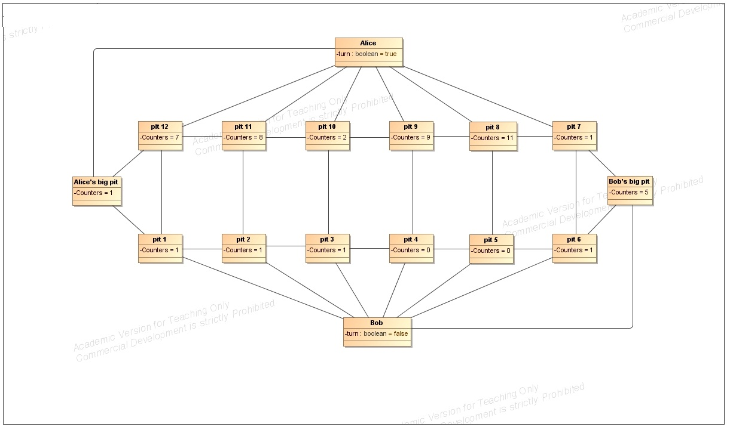

11.

Title: Alice makes a move from pit 7

Preconditions: the pits on the board contain the following amount of counters: pit 1 – 1, pit

2 – 1, pit 3 – 1, pit 4 – 0, pit 5 – 0, pit 6 – 1, pit 7 – 1, pit 8 – 11, pit 9 – 9, pit 10 – 2, pit 11 – 8, pit 12– 7. There are 5 counters in Bob’s big pit and 1 counter in Alice’s big pit.

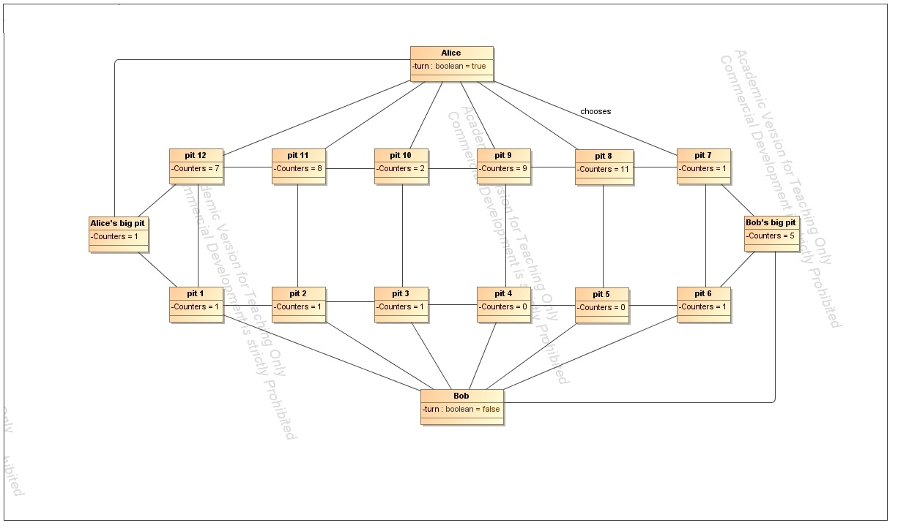

Postconditions: the pits on the board contain the following amount of counters: pit 1 – 1, pit

2 – 1, pit 3 – 1, pit 4 – 0, pit 5 – 0, pit 6 – 1, pit 7 – 0, pit 8 – 12, pit 9 – 9, pit 10 – 2, pit 11 – 8, pit 12– 7. There are 5 counters in Bob’s big pit and 1 counter in Alice’s big pit.

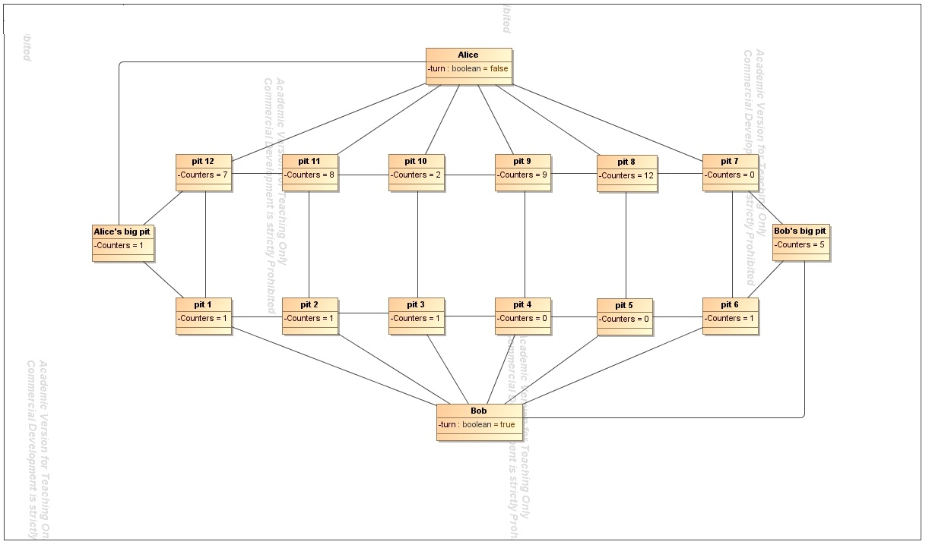

12.

Title: Bob makes a move from pit 6

Preconditions: the pits on the board contain the following amount of counters: pit 1 – 1, pit

2 – 1, pit 3 – 1, pit 4 – 0, pit 5 – 0, pit 6 – 1, pit 7 – 0, pit 8 – 12, pit 9 – 9, pit 10 – 2, pit 11 – 8, pit 12– 7. There are 5 counters in Bob’s big pit and 1 counter in Alice’s big pit.

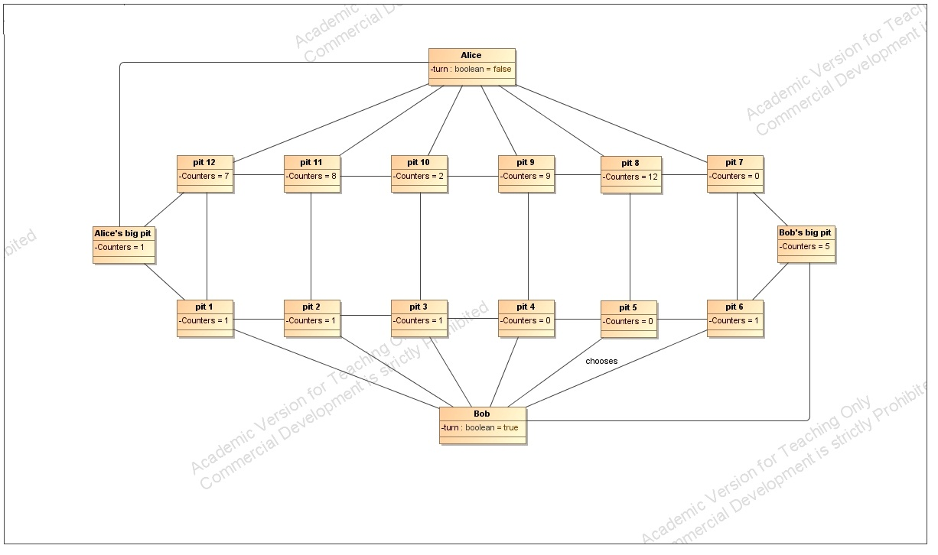

Postconditions: the pits on the board contain the following amount of counters: pit 1 – 1, pit

2 – 1, pit 3 – 1, pit 4 – 0, pit 5 – 0, pit 6 – 0, pit 7 – 0, pit 8 – 12, pit 9 – 9, pit 10 – 2, pit 11 – 8, pit 12– 7. There are 6 counters in Bob’s big pit and 1 counter in Alice’s big pit. Bob gets an additional move.

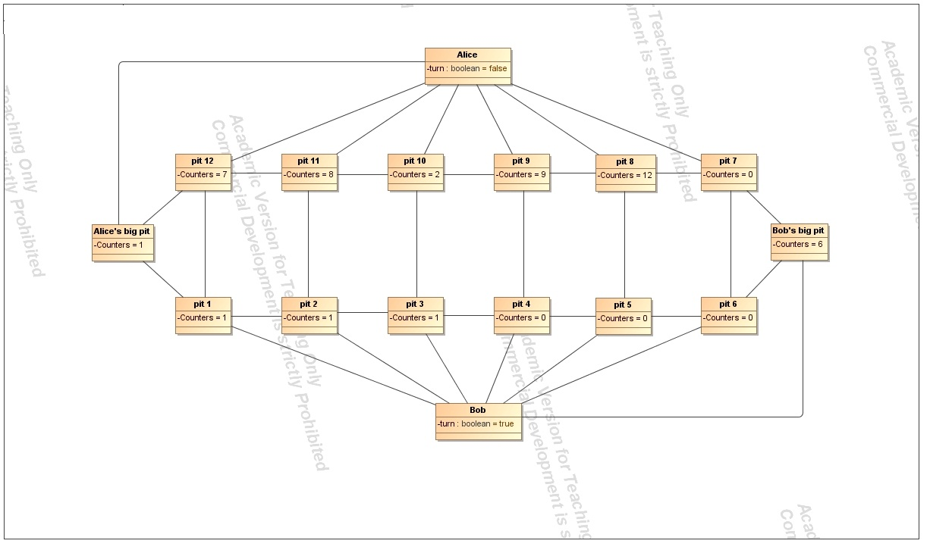

13.

Title: Bob makes a move from pit 3

Preconditions: the pits on the board contain the following amount of counters: pit 1 – 1, pit

2 – 1, pit 3 – 1, pit 4 – 0, pit 5 – 0, pit 6 – 0, pit 7 – 0, pit 8 – 12, pit 9 – 9, pit 10 – 2, pit 11 – 8, pit 12– 7. There are 6 counters in Bob’s big pit and 1 counter in Alice’s big pit.

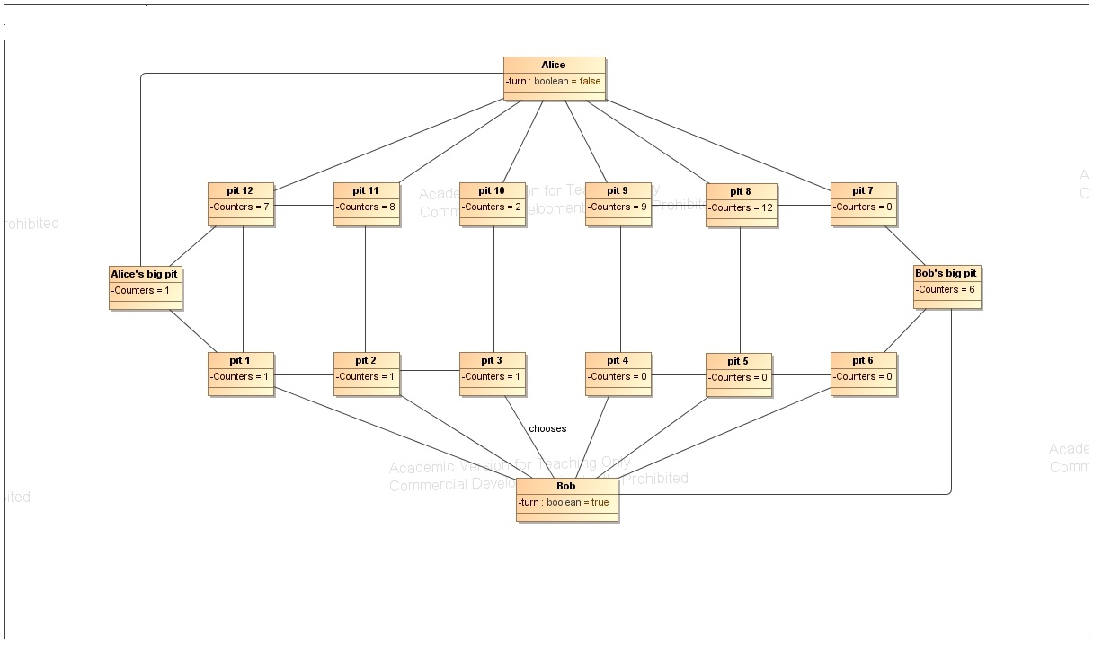

Postconditions: the pits on the board contain the following amount of counters: pit 1 – 1, pit

2 – 1, pit 3 – 0, pit 4 – 0, pit 5 – 0, pit 6 – 0, pit 7 – 0, pit 8 – 12, pit 9 – 0, pit 10 – 2, pit 11 – 8, pit 12– 7. There are 16 counters in Bob’s big pit and 1 counter in Alice’s big pit.

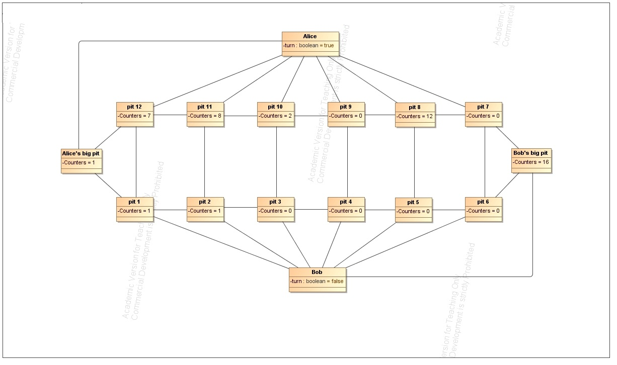

14.

Title: Alice makes a move from pit 8

Preconditions: the pits on the board contain the following amount of counters: pit 1 – 1, pit

2 – 1, pit 3 – 0, pit 4 – 0, pit 5 – 0, pit 6 – 0, pit 7 – 0, pit 8 – 12, pit 9 – 0, pit 10 – 2, pit 11 – 8, pit 12– 7. There are 16 counters in Bob’s big pit and 1 counter in Alice’s big pit.

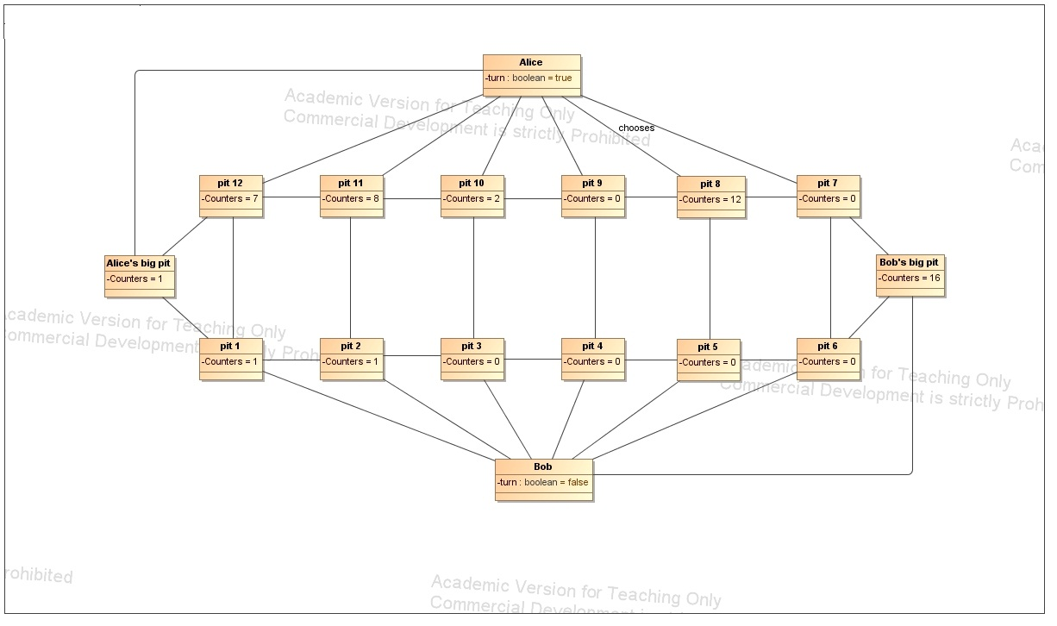

Postconditions: the pits on the board contain the following amount of counters: pit 1 – 2, pit

2 – 2, pit 3 – 1, pit 4 – 1, pit 5 – 1, pit 6 – 0, pit 7 – 0, pit 8 – 0, pit 9 – 1, pit 10 – 3, pit 11 – 9, pit 12– 8. There are 16 counters in Bob’s big pit and 4 counters in Alice’s big pit.

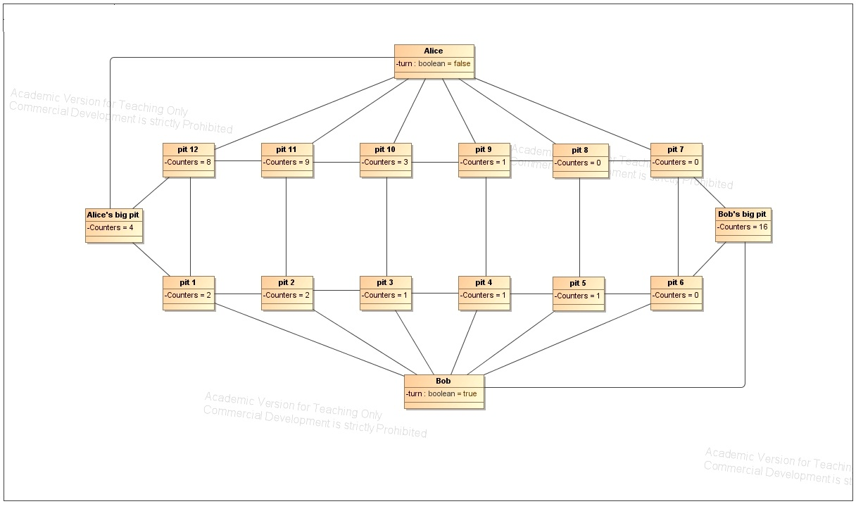

15.

Title: Bob makes a move from pit 1

Preconditions: the pits on the board contain the following amount of counters: pit 1 – 2, pit

2 – 2, pit 3 – 1, pit 4 – 1, pit 5 – 1, pit 6 – 0, pit 7 – 0, pit 8 – 0, pit 9 – 1, pit 10 – 3, pit 11 – 9, pit 12– 8. There are 16 counters in Bob’s big pit and 4 counters in Alice’s big pit.

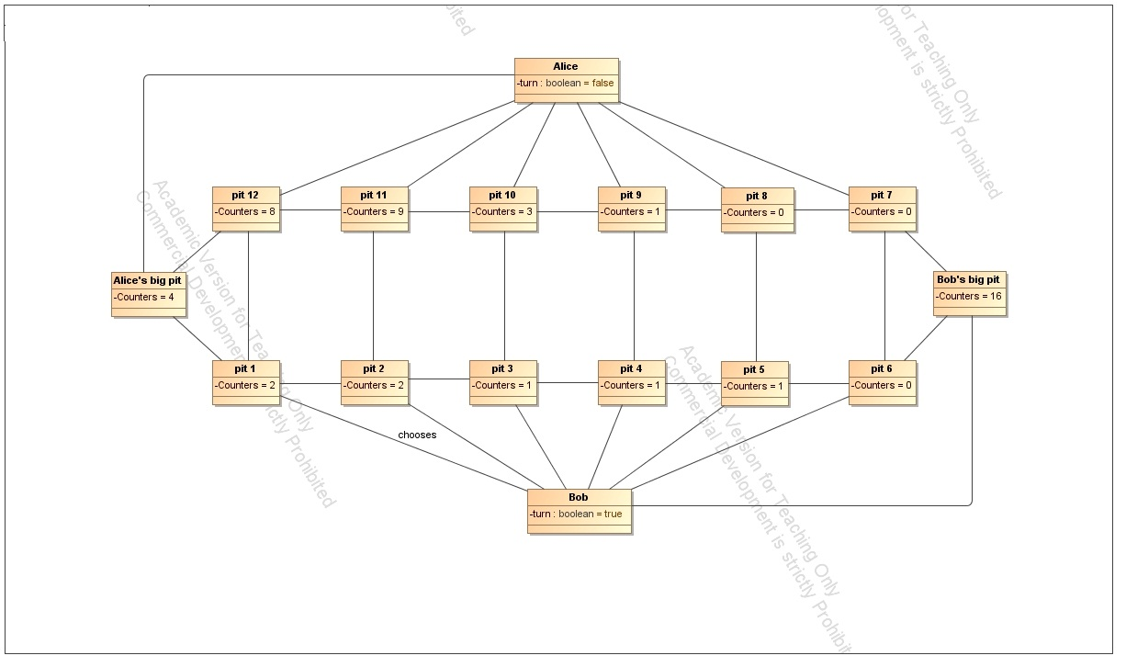

Postconditions: the pits on the board contain the following amount of counters: pit 1 – 0, pit

2 – 3, pit 3 – 2, pit 4 – 1, pit 5 – 1, pit 6 – 0, pit 7 – 0, pit 8 – 0, pit 9 – 1, pit 10 – 3, pit 11 – 9, pit 12– 8. There are 16 counters in Bob’s big pit and 4 counters in Alice’s big pit.

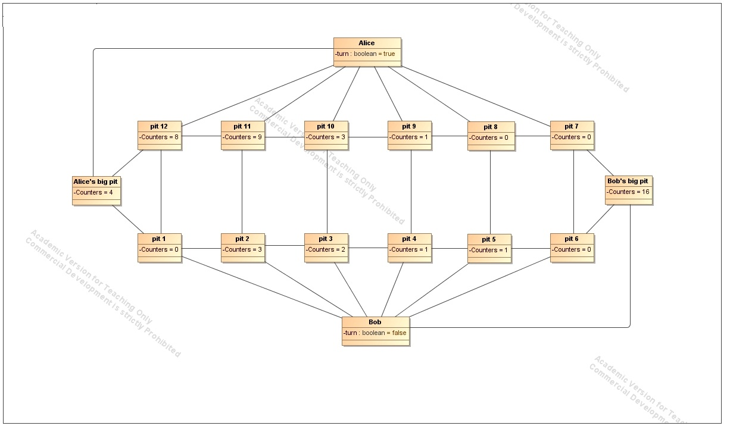

16.

Title: Alice makes a move from pit 9

Preconditions: the pits on the board contain the following amount of counters: pit 1 – 0, pit

2 – 3, pit 3 – 2, pit 4 – 1, pit 5 – 1, pit 6 – 0, pit 7 – 0, pit 8 – 0, pit 9 – 1, pit 10 – 3, pit 11 – 9, pit 12– 8. There are 16 counters in Bob’s big pit and 4 counters in Alice’s big pit.

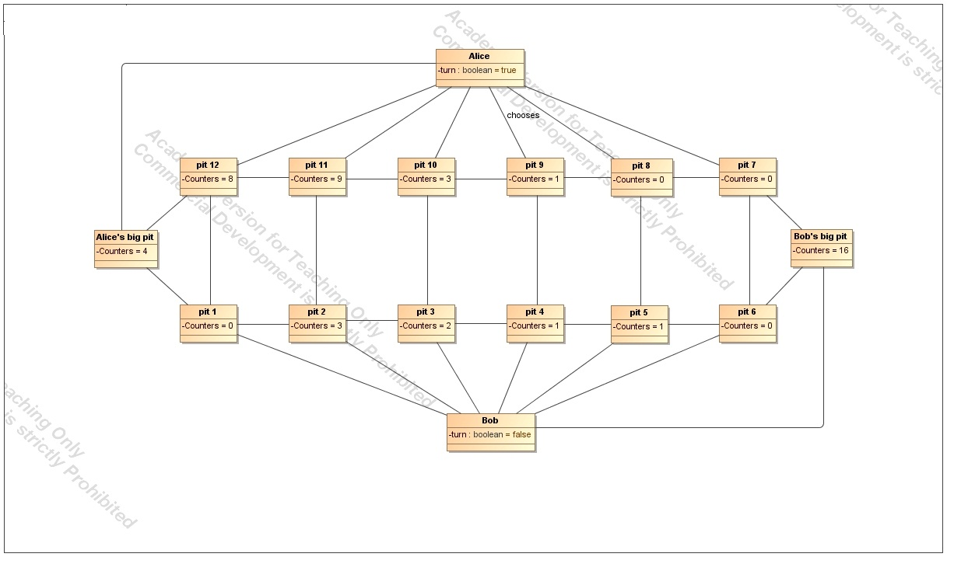

Postconditions: the pits on the board contain the following amount of counters: pit 1 – 0, pit

2 – 3, pit 3 – 2, pit 4 – 1, pit 5 – 1, pit 6 – 0, pit 7 – 0, pit 8 – 0, pit 9 – 0, pit 10 – 4, pit 11 – 9, pit 12– 8. There are 16 counters in Bob’s big pit and 4 counters in Alice’s big pit.

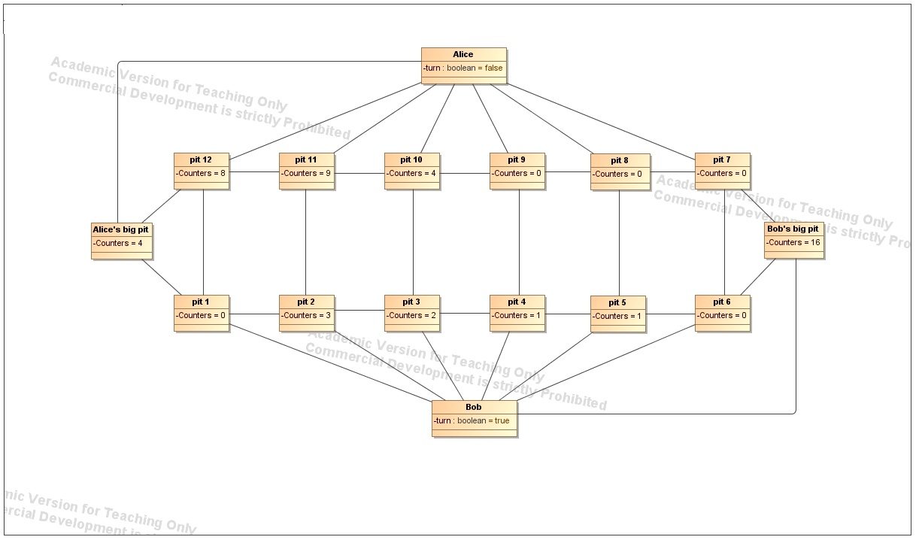

17.

Title: Bob makes a move from pit 2

Preconditions: the pits on the board contain the following amount of counters: pit 1 – 0, pit

2 – 3, pit 3 – 2, pit 4 – 1, pit 5 – 1, pit 6 – 0, pit 7 – 0, pit 8 – 0, pit 9 – 0, pit 10 – 4, pit 11 – 9, pit 12– 8. There are 16 counters in Bob’s big pit and 4 counters in Alice’s big pit.

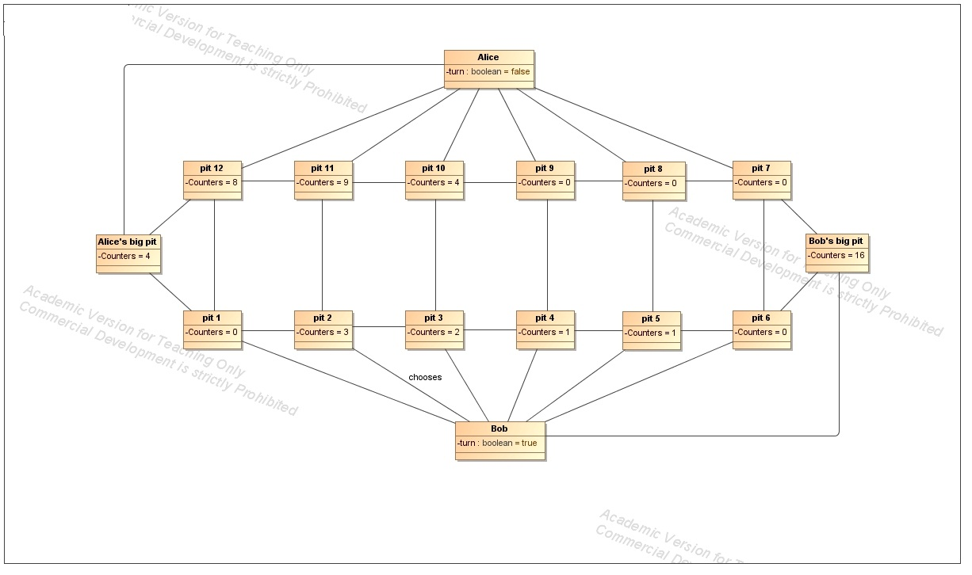

Postconditions: the pits on the board contain the following amount of counters: pit 1 – 0, pit

2 – 0, pit 3 – 3, pit 4 – 2, pit 5 – 2, pit 6 – 0, pit 7 – 0, pit 8 – 0, pit 9 – 0, pit 10 – 4, pit 11 – 9, pit 12– 8. There are 16 counters in Bob’s big pit and 4 counters in Alice’s big pit.

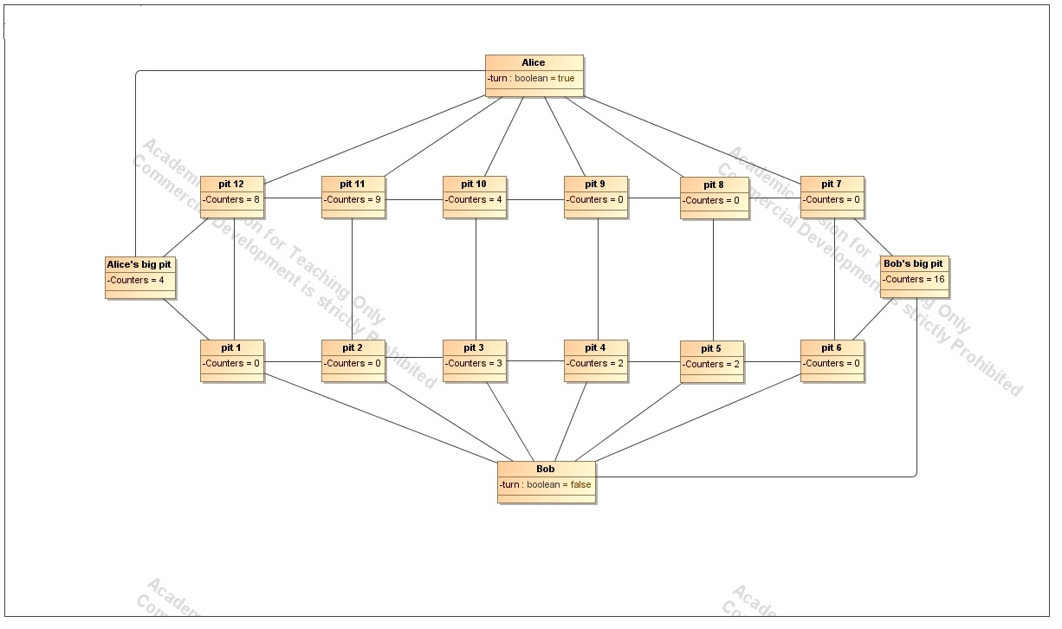

18.

Title: Alice makes a move from pit 10

Preconditions: the pits on the board contain the following amount of counters: pit 1 – 0, pit

2 – 0, pit 3 – 3, pit 4 – 2, pit 5 – 2, pit 6 – 0, pit 7 – 0, pit 8 – 0, pit 9 – 0, pit 10 – 4, pit 11 – 9, pit 12– 8. There are 16 counters in Bob’s big pit and 4 counters in Alice’s big pit.

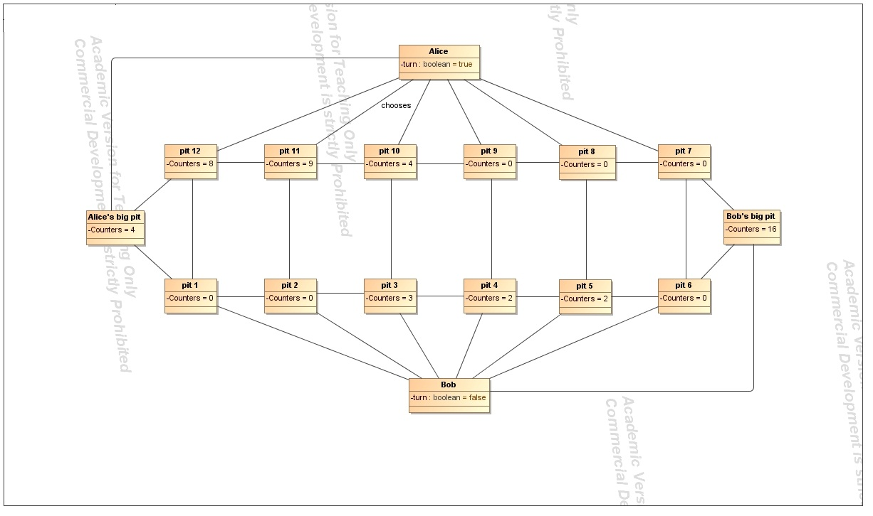

Postconditions: the pits on the board contain the following amount of counters: pit 1 – 1, pit

2 – 0, pit 3 – 3, pit 4 – 2, pit 5 – 2, pit 6 – 0, pit 7 – 0, pit 8 – 0, pit 9 – 0, pit 10 – 0, pit 11 – 10, pit 12– 9. There are 16 counters in Bob’s big pit and 5 counters in Alice’s big pit.

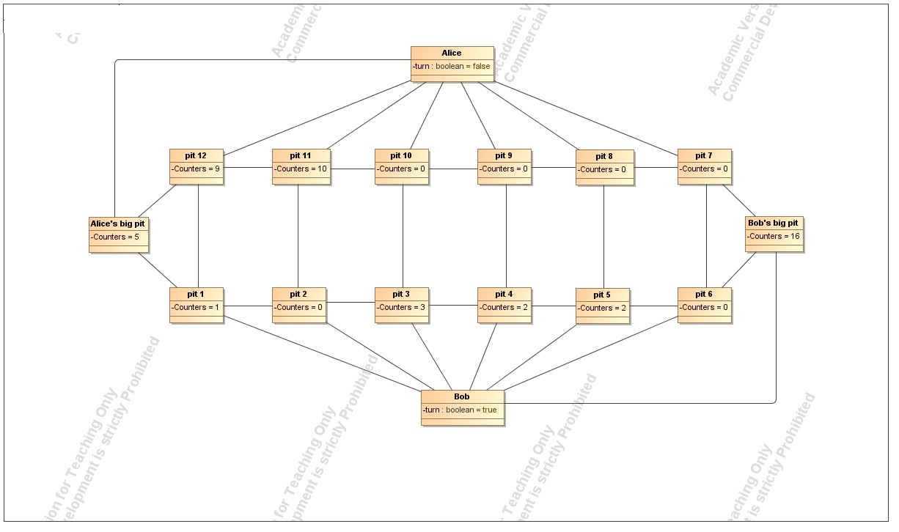

19.

Title: Bob makes a move from pit 5

Preconditions: the pits on the board contain the following amount of counters: pit 1 – 1, pit

2 – 0, pit 3 – 3, pit 4 – 2, pit 5 – 2, pit 6 – 0, pit 7 – 0, pit 8 – 0, pit 9 – 0, pit 10 – 0, pit 11 – 10, pit 12– 9. There are 16 counters in Bob’s big pit and 5 counters in Alice’s big pit.

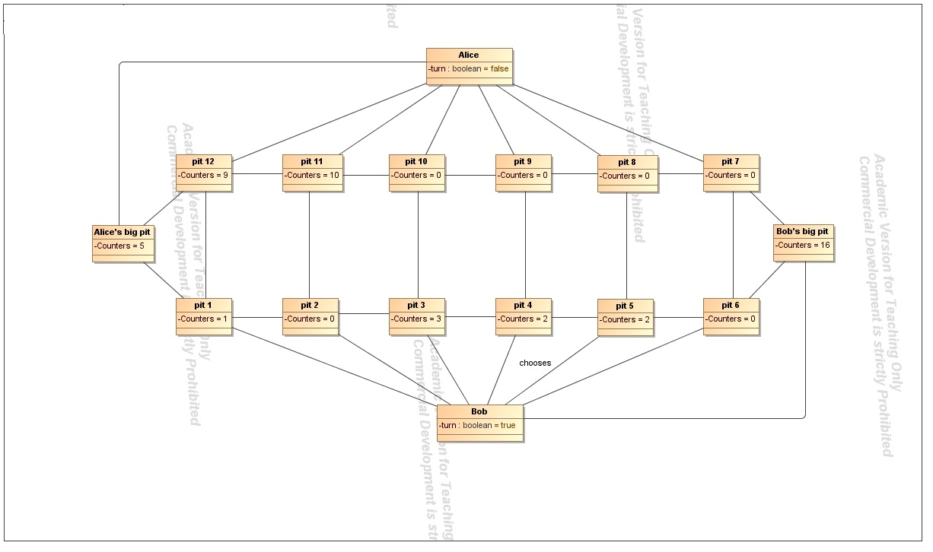

Postconditions: the pits on the board contain the following amount of counters: pit 1 – 1, pit

2 – 0, pit 3 – 3, pit 4 – 2, pit 5 – 0, pit 6 – 1, pit 7 – 0, pit 8 – 0, pit 9 – 0, pit 10 – 0, pit 11 – 10, pit 12– 9. There are 17 counters in Bob’s big pit and 5 counters in Alice’s big pit. Bob gets an additional move.

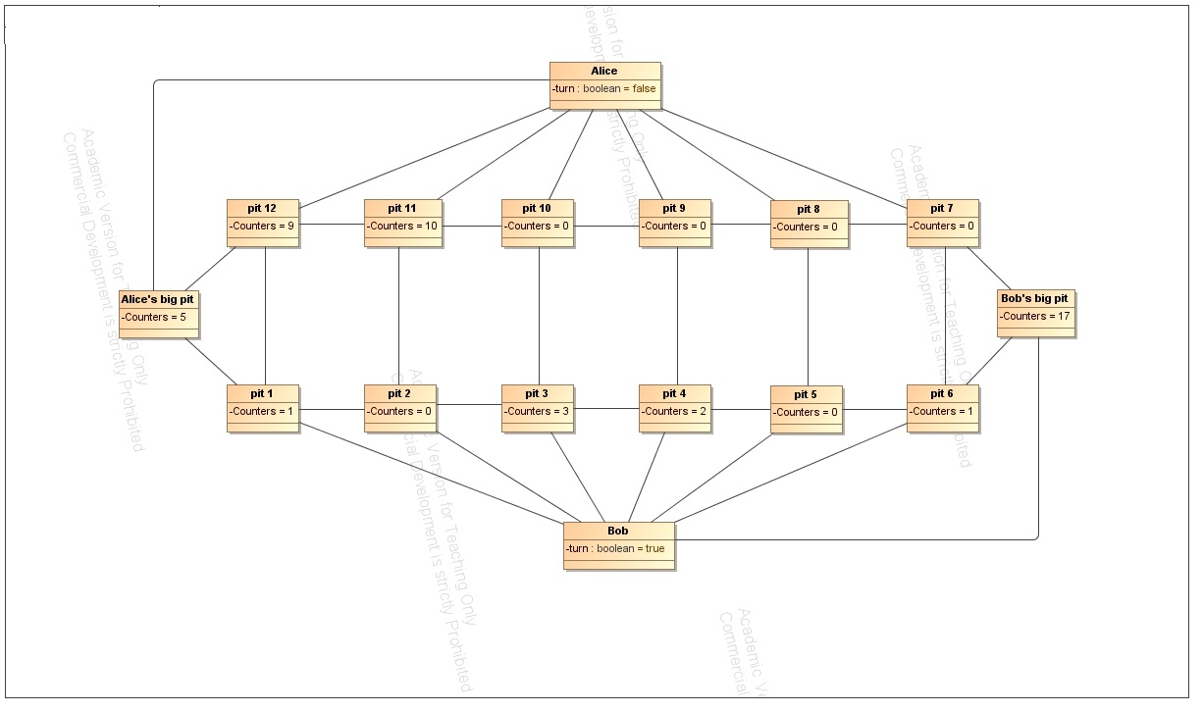

20.

Title: Bob makes a move from pit 6

Preconditions: the pits on the board contain the following amount of counters: pit 1 – 1, pit

2 – 0, pit 3 – 3, pit 4 – 2, pit 5 – 0, pit 6 – 1, pit 7 – 0, pit 8 – 0, pit 9 – 0, pit 10 – 0, pit 11 – 10, pit 12– 9. There are 17 counters in Bob’s big pit and 5 counters in Alice’s big pit.

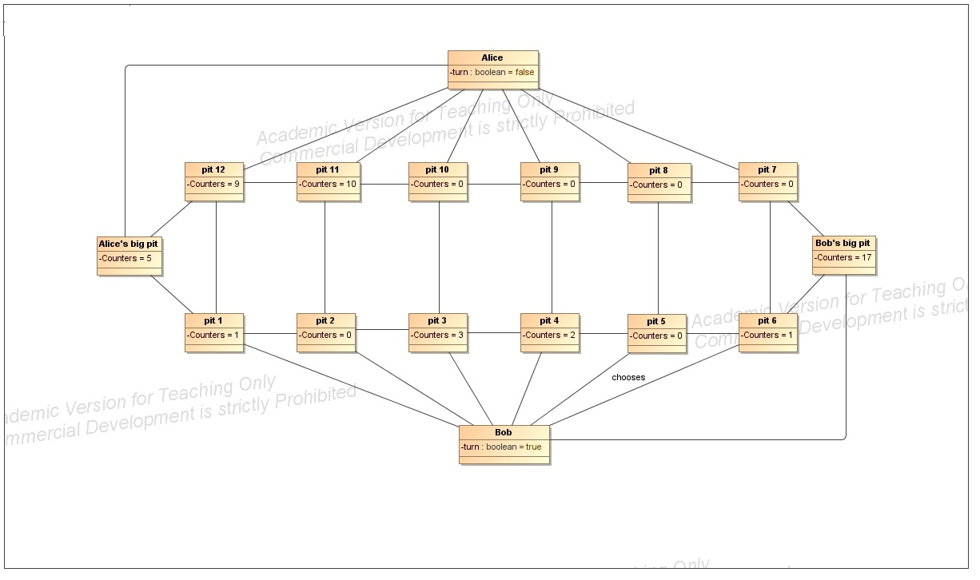

Postconditions: the pits on the board contain the following amount of counters: pit 1 – 1, pit

2 – 0, pit 3 – 3, pit 4 – 2, pit 5 – 0, pit 6 – 0, pit 7 – 0, pit 8 – 0, pit 9 – 0, pit 10 – 0, pit 11 – 10, pit 12– 9. There are 18 counters in Bob’s big pit and 5 counters in Alice’s big pit.

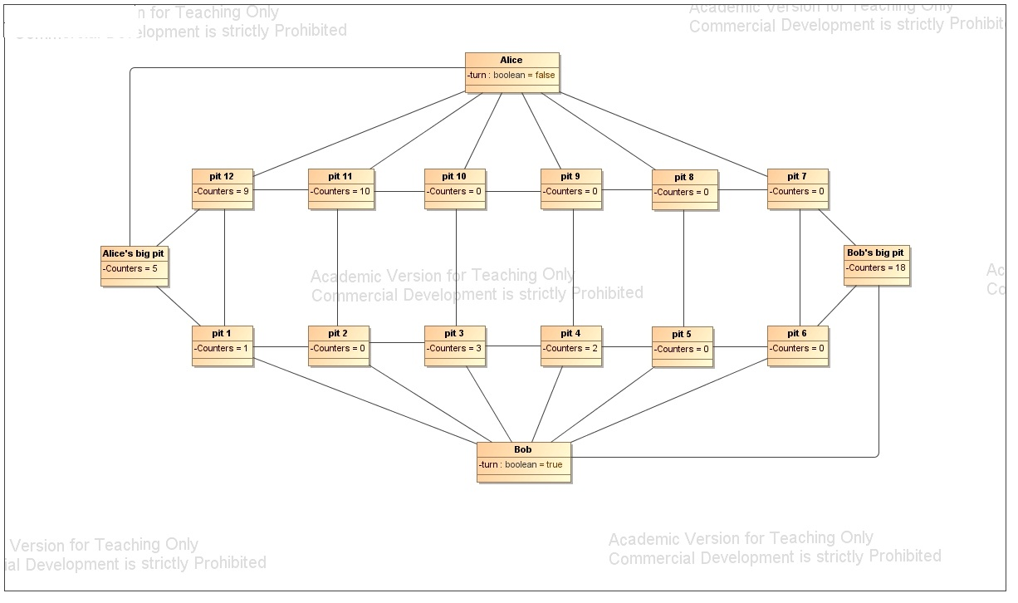

21.

Title: Bob makes a move from pit 3

Preconditions: the pits on the board contain the following amount of counters: pit 1 – 1, pit

2 – 0, pit 3 – 3, pit 4 – 2, pit 5 – 0, pit 6 – 0, pit 7 – 0, pit 8 – 0, pit 9 – 0, pit 10 – 0, pit 11 – 10, pit 12– 9. There are 18 counters in Bob’s big pit and 5 counters in Alice’s big pit.

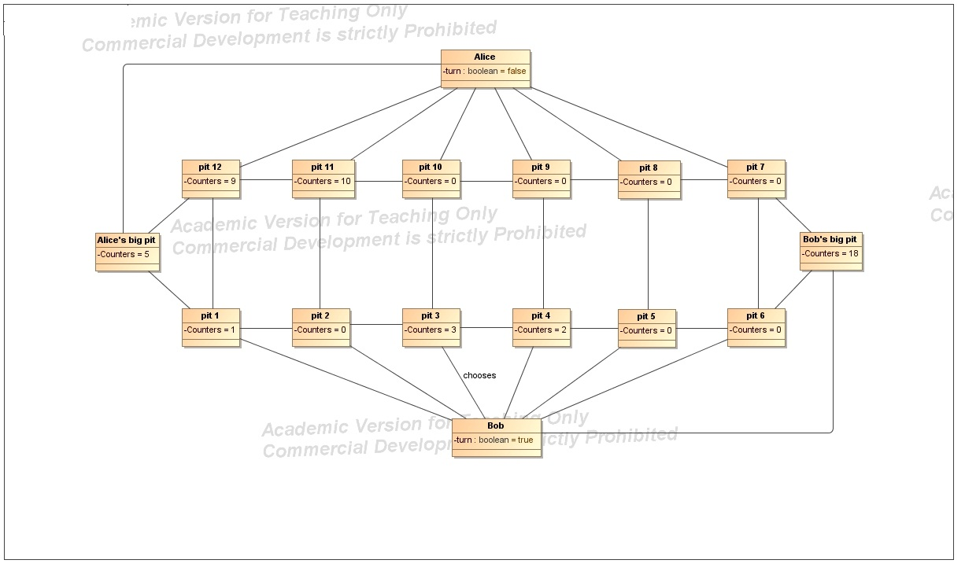

Postconditions: the pits on the board contain the following amount of counters: pit 1 – 1, pit

2 – 0, pit 3 – 0, pit 4 – 3, pit 5 – 1, pit 6 – 1, pit 7 – 0, pit 8 – 0, pit 9 – 0, pit 10 – 0, pit 11 – 10, pit 12– 9. There are 18 counters in Bob’s big pit and 5 counters in Alice’s big pit.

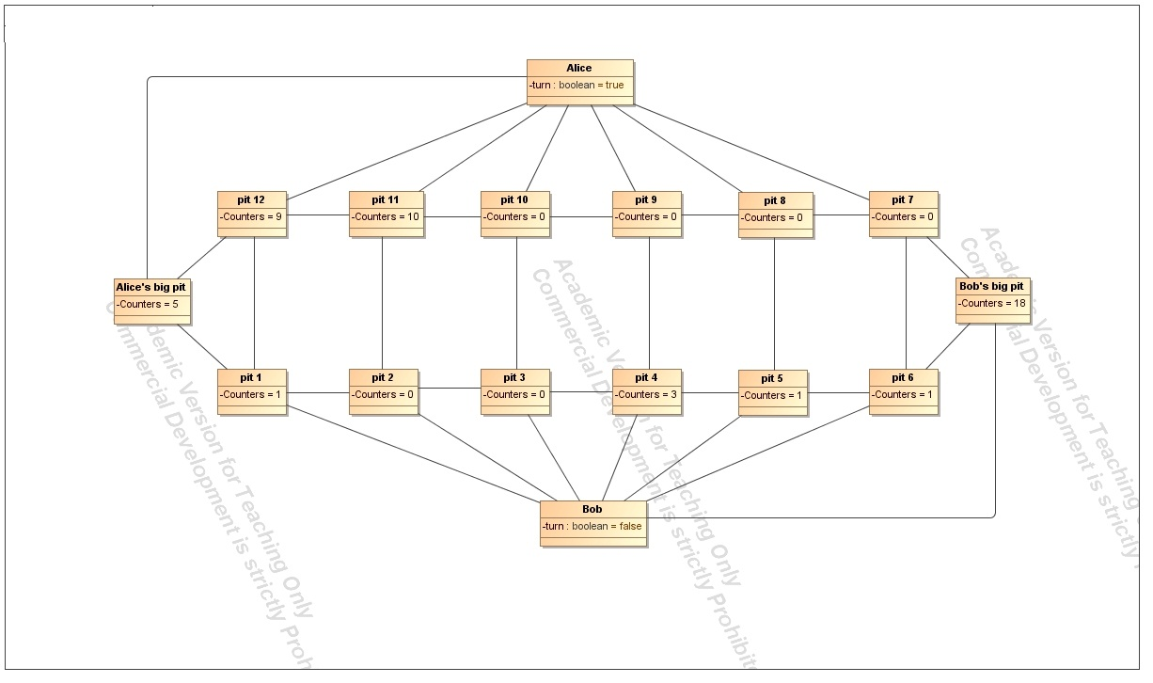

22.

Title: Alice makes a move from pit 11

Preconditions: the pits on the board contain the following amount of counters: pit 1 – 1, pit

2 – 0, pit 3 – 0, pit 4 – 3, pit 5 – 1, pit 6 – 1, pit 7 – 0, pit 8 – 0, pit 9 – 0, pit 10 – 0, pit 11 – 10, pit 12– 9. There are 18 counters in Bob’s big pit and 5 counters in Alice’s big pit.

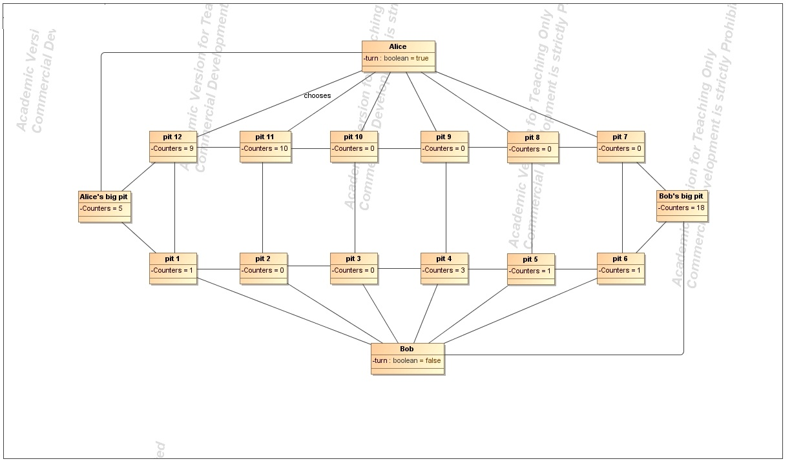

Postconditions: the pits on the board contain the following amount of counters: pit 1 – 2, pit

2 – 1, pit 3 – 1, pit 4 – 4, pit 5 – 0, pit 6 – 2, pit 7 – 1, pit 8 – 0, pit 9 – 0, pit 10 – 0, pit 11 – 0, pit 12– 10. There are 18 counters in Bob’s big pit and 9 counters in Alice’s big pit.

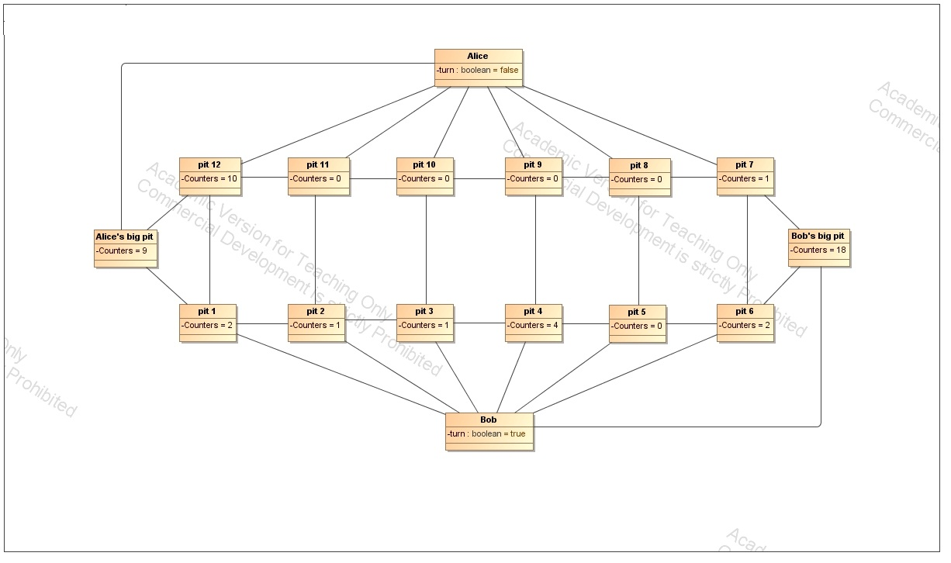

23.

Title: Bob makes a move from pit 6

Preconditions: the pits on the board contain the following amount of counters: pit 1 – 2, pit

2 – 1, pit 3 – 1, pit 4 – 4, pit 5 – 0, pit 6 – 2, pit 7 – 1, pit 8 – 0, pit 9 – 0, pit 10 – 0, pit 11 – 0, pit 12– 10. There are 18 counters in Bob’s big pit and 9 counters in Alice’s big pit.

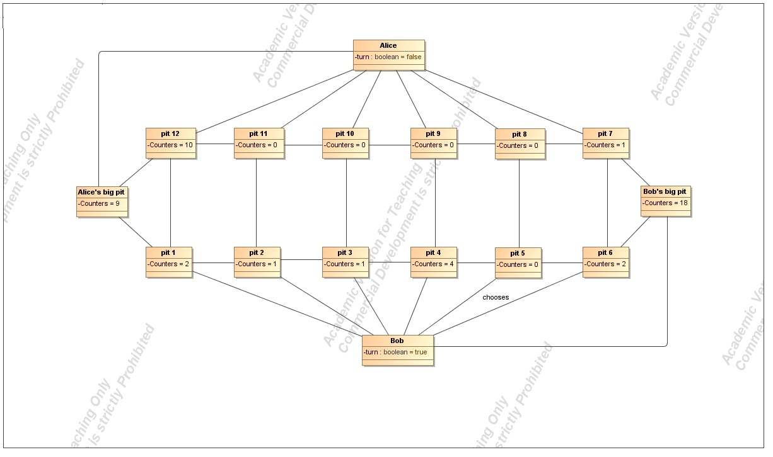

Postconditions: the pits on the board contain the following amount of counters: pit 1 – 2, pit

2 – 1, pit 3 – 1, pit 4 – 4, pit 5 – 0, pit 6 – 0, pit 7 – 2, pit 8 – 0, pit 9 – 0, pit 10 – 0, pit 11 – 0, pit 12– 10. There are 19 counters in Bob’s big pit and 9 counters in Alice’s big pit.

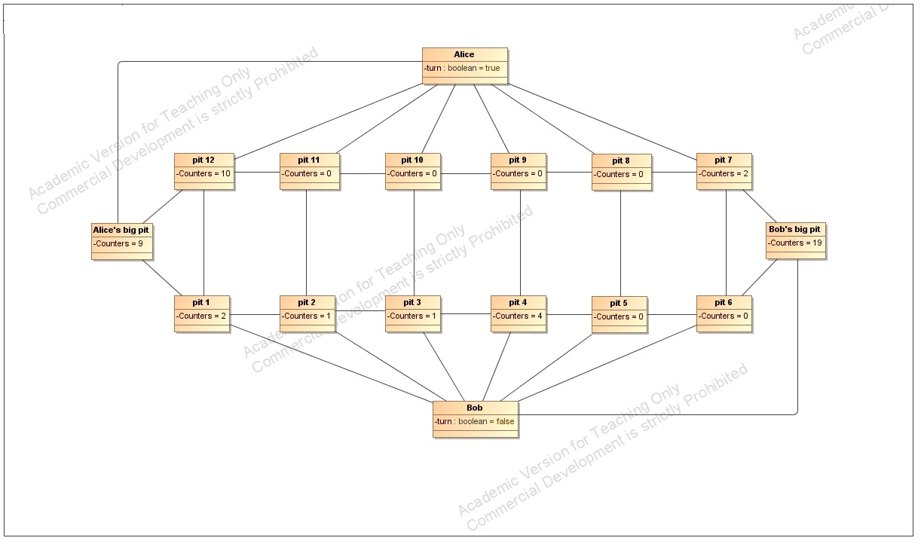

24.

Title: Alice makes a move from pit 7

Preconditions: the pits on the board contain the following amount of counters: pit 1 – 2, pit

2 – 1, pit 3 – 1, pit 4 – 4, pit 5 – 0, pit 6 – 0, pit 7 – 2, pit 8 – 0, pit 9 – 0, pit 10 – 0, pit 11 – 0, pit 12– 10. There are 19 counters in Bob’s big pit and 9 counters in Alice’s big pit.

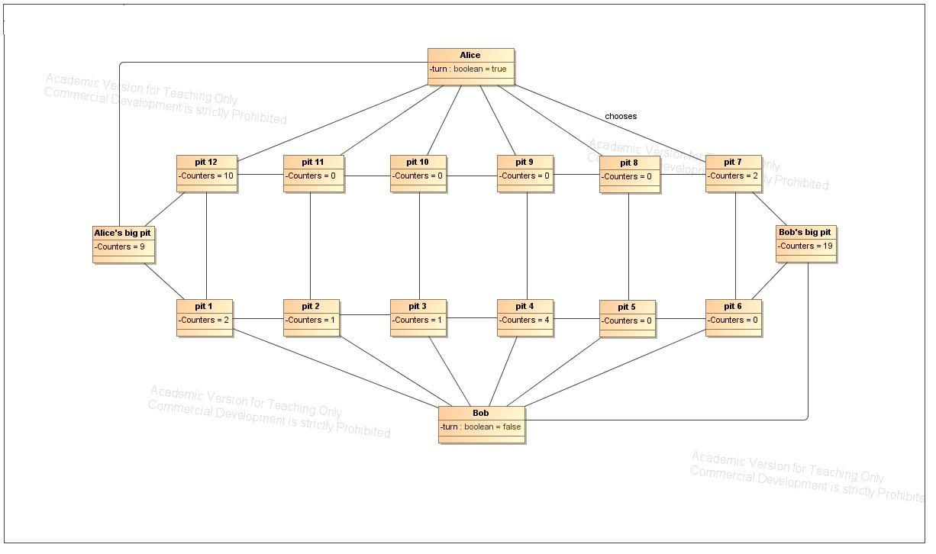

Postconditions: the pits on the board contain the following amount of counters: pit 1 – 2, pit

2 – 1, pit 3 – 1, pit 4 – 0, pit 5 – 0, pit 6 – 0, pit 7 – 0, pit 8 – 1, pit 9 – 0, pit 10 – 0, pit 11 – 0, pit 12– 10. There are 19 counters in Bob’s big pit and 14 counters in Alice’s big pit.

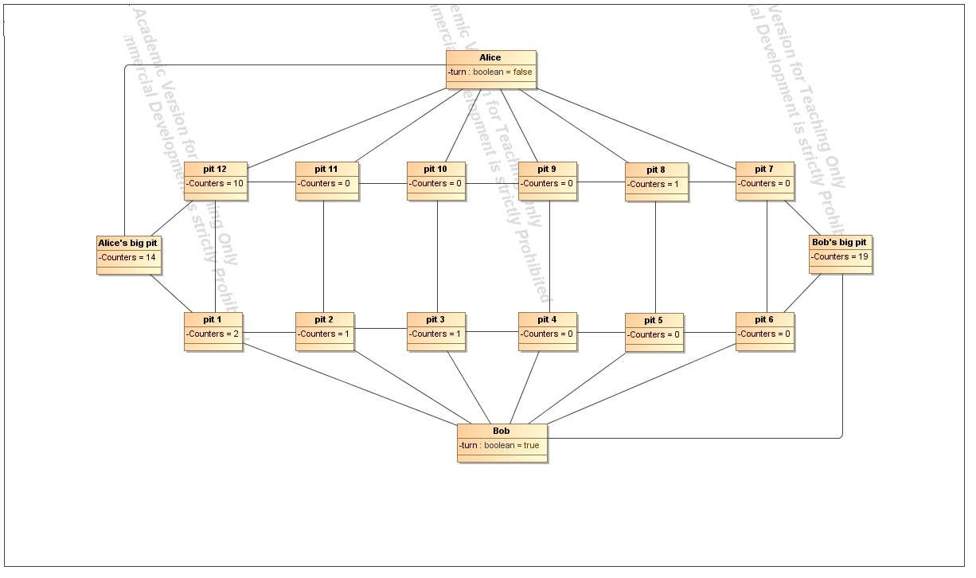

25.

Title: Bob makes a move from pit 3

Preconditions: the pits on the board contain the following amount of counters: pit 1 – 2, pit

2 – 1, pit 3 – 1, pit 4 – 0, pit 5 – 0, pit 6 – 0, pit 7 – 0, pit 8 – 1, pit 9 – 0, pit 10 – 0, pit 11 – 0, pit 12– 10. There are 19 counters in Bob’s big pit and 14 counters in Alice’s big pit.

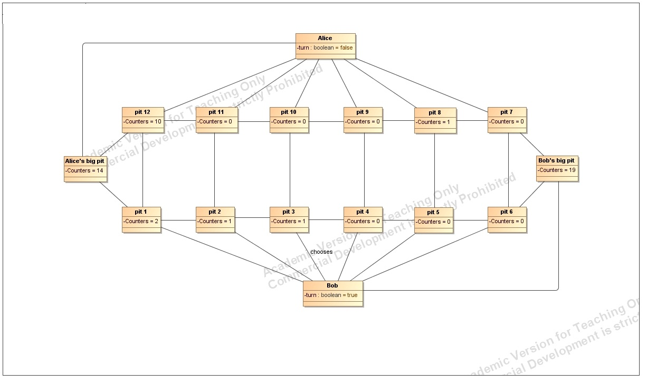

Postconditions: the pits on the board contain the following amount of counters: pit 1 – 2, pit

2 – 1, pit 3 – 0, pit 4 – 1, pit 5 – 0, pit 6 – 0, pit 7 – 0, pit 8 – 1, pit 9 – 0, pit 10 – 0, pit 11 – 0, pit 12– 10. There are 19 counters in Bob’s big pit and 14 counters in Alice’s big pit.

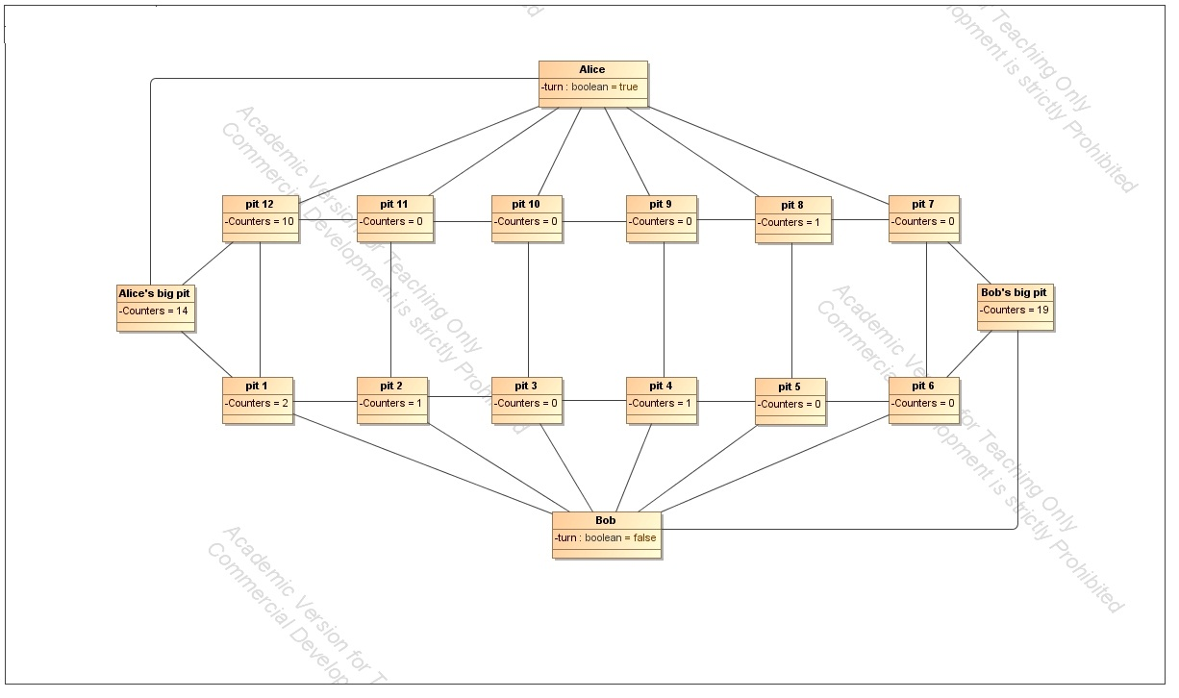

26.

Title: Alice makes a move from pit 8

Preconditions: the pits on the board contain the following amount of counters: pit 1 – 2, pit

2 – 1, pit 3 – 0, pit 4 – 1, pit 5 – 0, pit 6 – 0, pit 7 – 0, pit 8 – 1, pit 9 – 0, pit 10 – 0, pit 11 – 0, pit 12– 10. There are 19 counters in Bob’s big pit and 14 counters in Alice’s big pit.

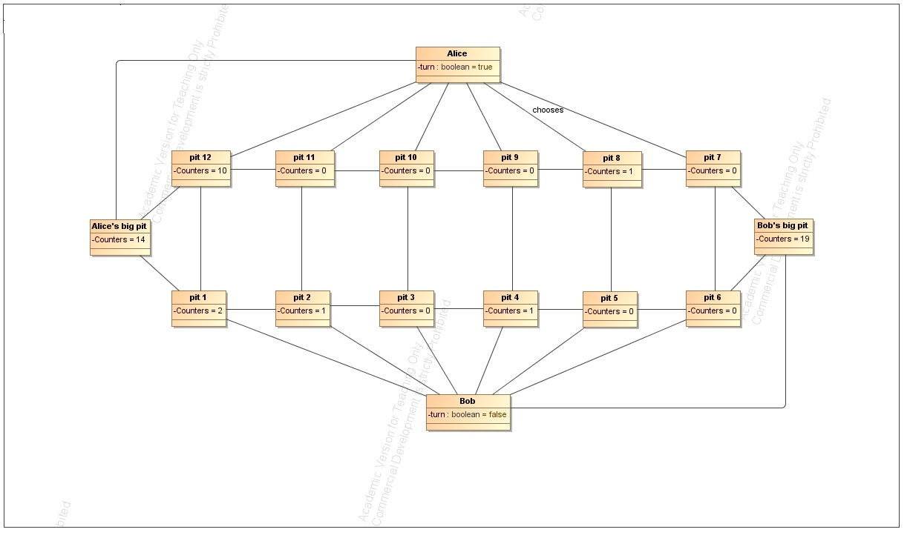

Postconditions: the pits on the board contain the following amount of counters: pit 1 – 2, pit

2 – 1, pit 3 – 0, pit 4 – 0, pit 5 – 0, pit 6 – 0, pit 7 – 0, pit 8 – 0, pit 9 – 0, pit 10 – 0, pit 11 – 0, pit 12– 10. There are 19 counters in Bob’s big pit and 16 counters in Alice’s big pit.

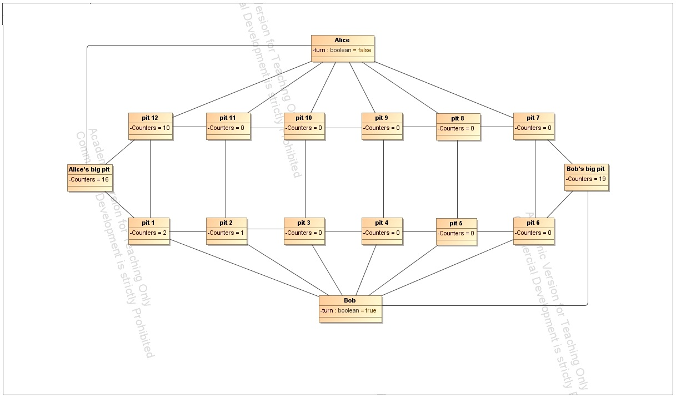

27.

Title: Bob makes a move from pit 1

Preconditions: the pits on the board contain the following amount of counters: pit 1 – 2, pit

2 – 1, pit 3 – 0, pit 4 – 0, pit 5 – 0, pit 6 – 0, pit 7 – 0, pit 8 – 0, pit 9 – 0, pit 10 – 0, pit 11 – 0, pit 12– 10. There are 19 counters in Bob’s big pit and 16 counters in Alice’s big pit.

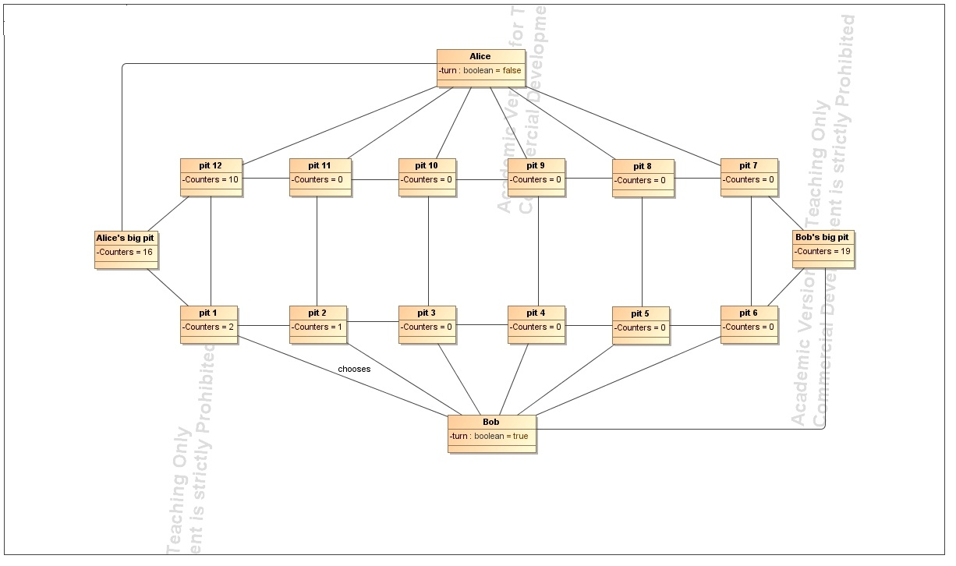

Postconditions: the pits on the board contain the following amount of counters: pit 1 – 0, pit

2 – 2, pit 3 – 1, pit 4 – 0, pit 5 – 0, pit 6 – 0, pit 7 – 0, pit 8 – 0, pit 9 – 0, pit 10 – 0, pit 11 – 0, pit 12– 10. There are 19 counters in Bob’s big pit and 16 counters in Alice’s big pit.

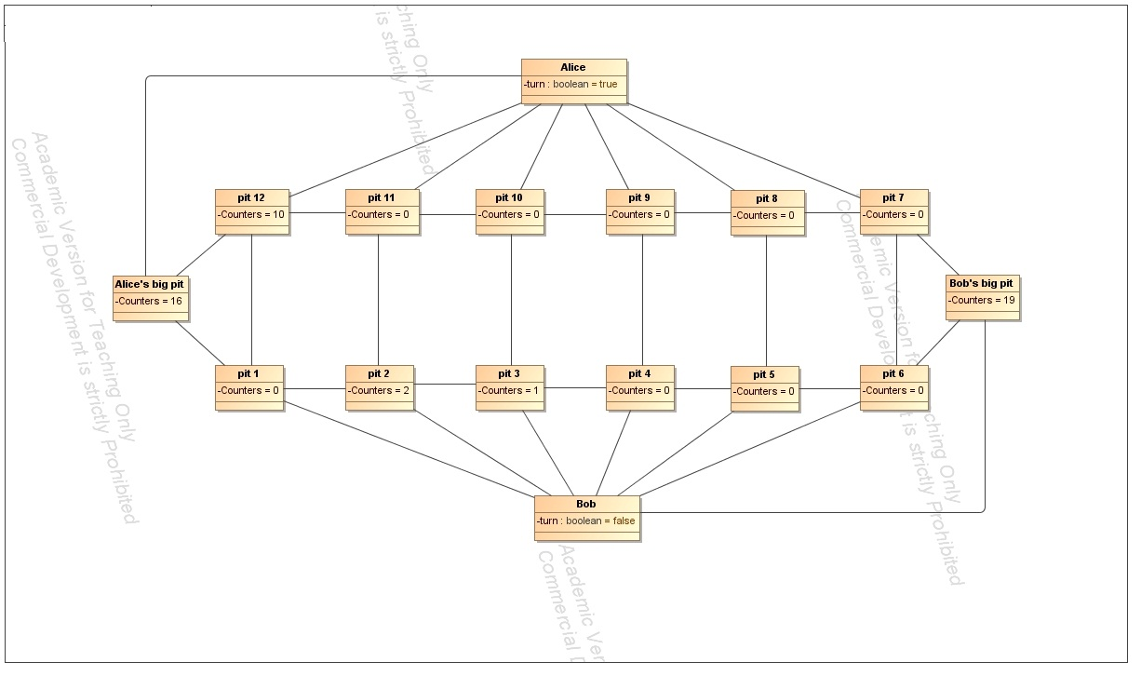

28.

Title: Alice makes a move from pit 12

Preconditions: the pits on the board contain the following amount of counters: pit 1 – 0, pit

2 – 2, pit 3 – 1, pit 4 – 0, pit 5 – 0, pit 6 – 0, pit 7 – 0, pit 8 – 0, pit 9 – 0, pit 10 – 0, pit 11 – 0, pit 12– 10. There are 19 counters in Bob’s big pit and 16 counters in Alice’s big pit.

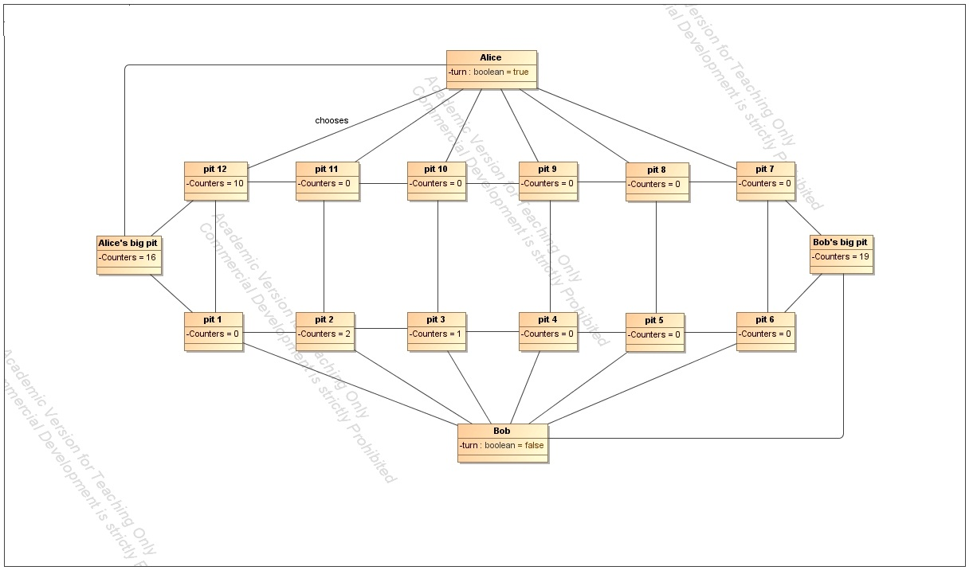

Postconditions: the pits on the board contain the following amount of counters: pit 1 – 1, pit

2 – 3, pit 3 – 2, pit 4 – 0, pit 5 – 1, pit 6 – 1, pit 7 – 1, pit 8 – 1, pit 9 – 0, pit 10 – 0, pit 11 – 0, pit 12– 0. There are 19 counters in Bob’s big pit and 19 counters in Alice’s big pit.

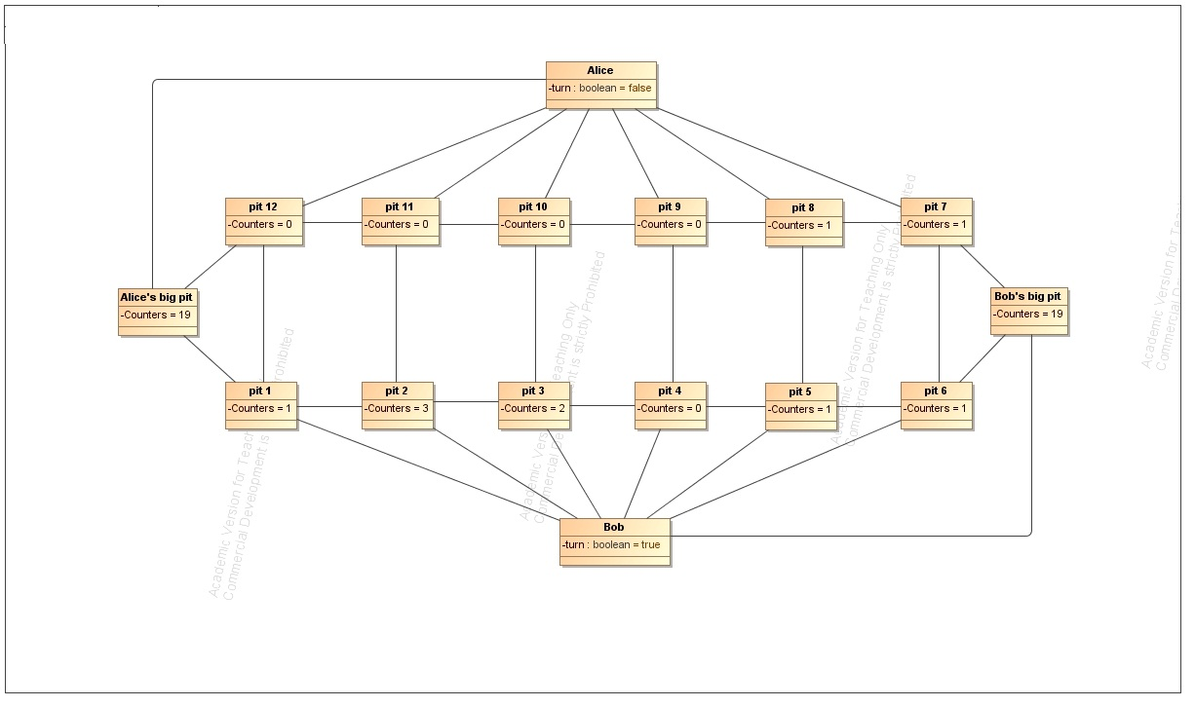

29.

Title: Bob makes a move from pit 6

Preconditions: the pits on the board contain the following amount of counters: pit 1 – 1, pit

2 – 3, pit 3 – 2, pit 4 – 0, pit 5 – 1, pit 6 – 1, pit 7 – 1, pit 8 – 1, pit 9 – 0, pit 10 – 0, pit 11 – 0, pit 12– 0. There are 19 counters in Bob’s big pit and 19 counters in Alice’s big pit.

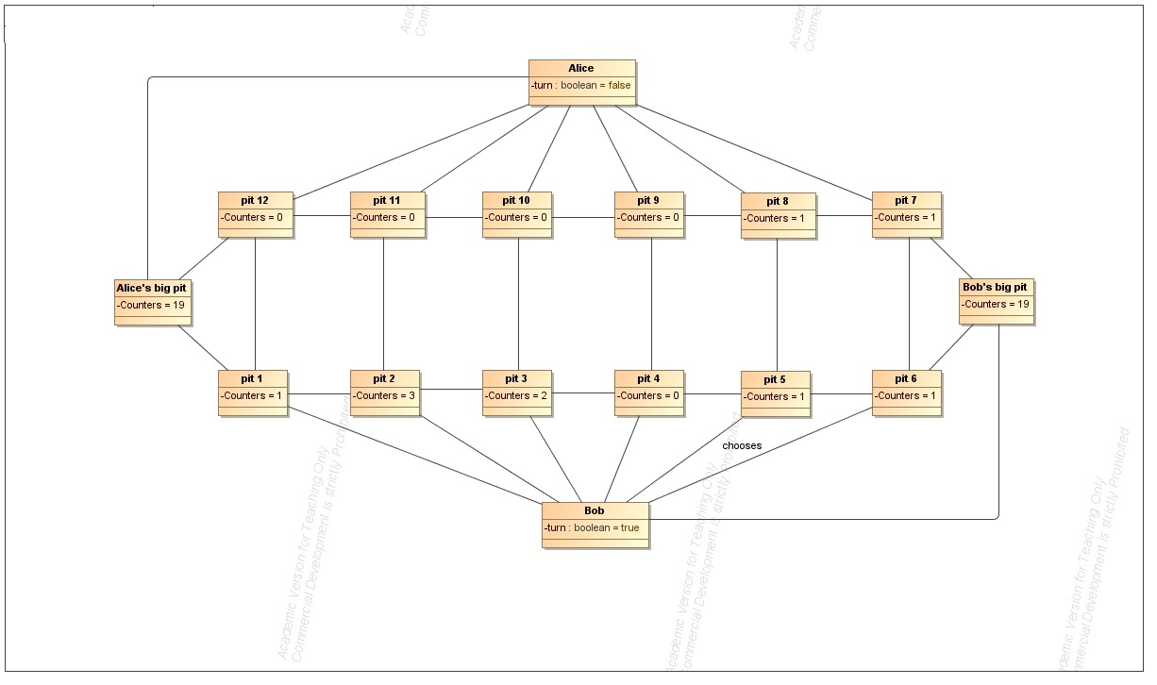

Postconditions: the pits on the board contain the following amount of counters: pit 1 – 1, pit

2 – 3, pit 3 – 2, pit 4 – 0, pit 5 – 1, pit 6 – 0, pit 7 – 1, pit 8 – 1, pit 9 – 0, pit 10 – 0, pit 11 – 0, pit 12– 0. There are 20 counters in Bob’s big pit and 19 counters in Alice’s big pit. Bob gets an additional move.

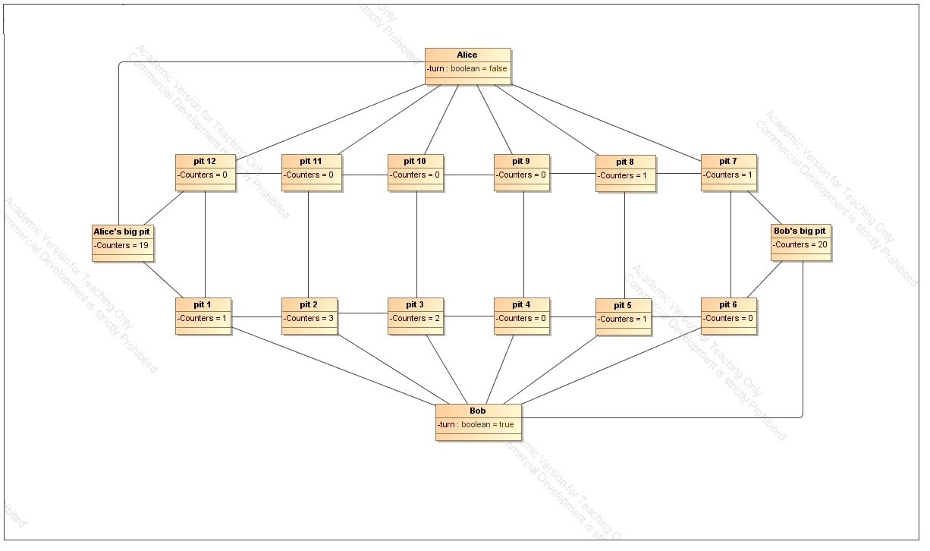

30.

Title: Bob makes a move from pit 5

Preconditions: the pits on the board contain the following amount of counters: pit 1 – 1, pit

2 – 3, pit 3 – 2, pit 4 – 0, pit 5 – 1, pit 6 – 0, pit 7 – 1, pit 8 – 1, pit 9 – 0, pit 10 – 0, pit 11 – 0, pit 12– 0. There are 20 counters in Bob’s big pit and 19 counters in Alice’s big pit.

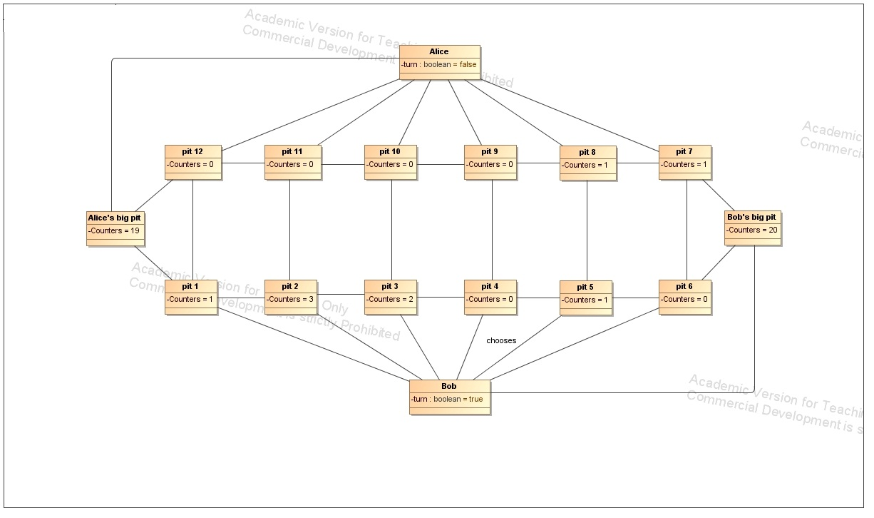

Postconditions: the pits on the board contain the following amount of counters: pit 1 – 1, pit

2 – 3, pit 3 – 2, pit 4 – 0, pit 5 – 0, pit 6 – 0, pit 7 – 0, pit 8 – 1, pit 9 – 0, pit 10 – 0, pit 11 – 0, pit 12– 0. There are 22 counters in Bob’s big pit and 19 counters in Alice’s big pit.

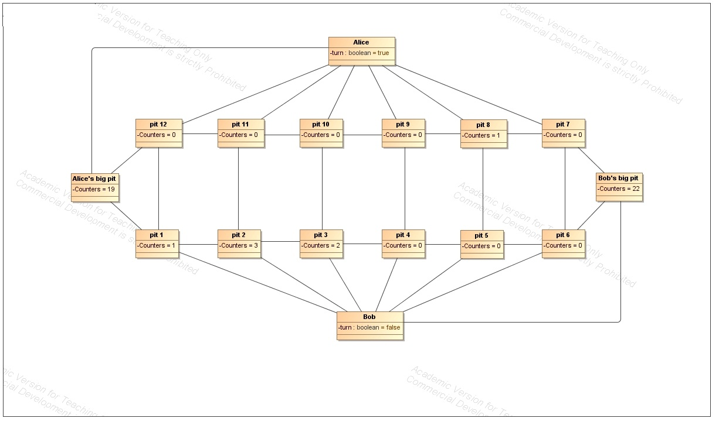

31.

Title: Alice makes a move from pit 8

Preconditions: the pits on the board contain the following amount of counters: pit 1 – 1, pit

2 – 3, pit 3 – 2, pit 4 – 0, pit 5 – 0, pit 6 – 0, pit 7 – 0, pit 8 – 1, pit 9 – 0, pit 10 – 0, pit 11 – 0, pit 12– 0. There are 22 counters in Bob’s big pit and 19 counters in Alice’s big pit.

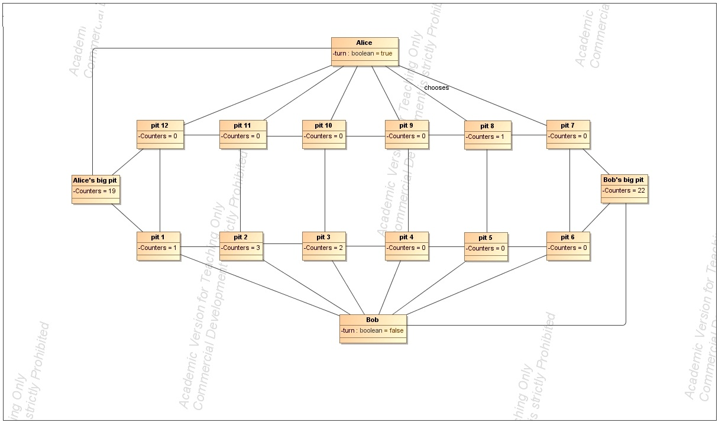

Postconditions: the pits on the board contain the following amount of counters: pit 1 – 1, pit

2 – 3, pit 3 – 2, pit 4 – 0, pit 5 – 0, pit 6 – 0, pit 7 – 0, pit 8 – 0, pit 9 – 1, pit 10 – 0, pit 11 – 0, pit 12– 0. There are 22 counters in Bob’s big pit and 19 counters in Alice’s big pit.

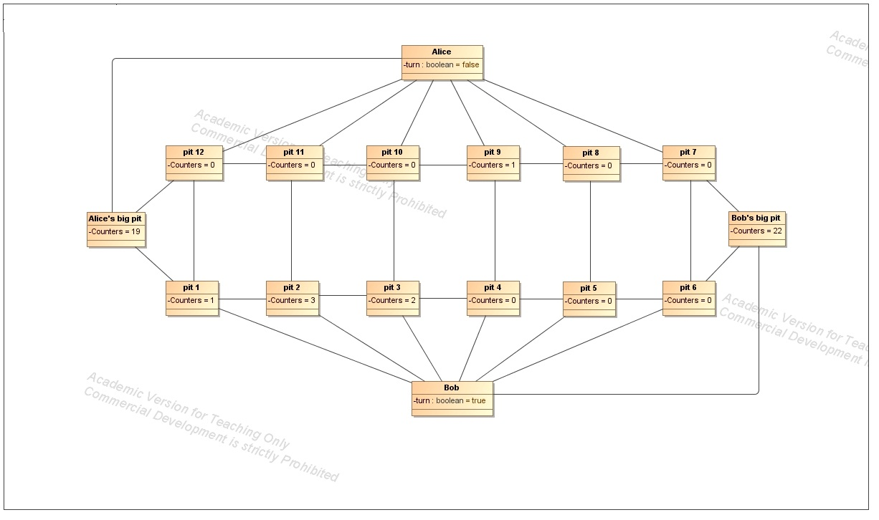

32.

Title: Bob makes a move from pit 1

Preconditions: the pits on the board contain the following amount of counters: pit 1 – 1, pit

2 – 3, pit 3 – 2, pit 4 – 0, pit 5 – 0, pit 6 – 0, pit 7 – 0, pit 8 – 0, pit 9 – 1, pit 10 – 0, pit 11 – 0, pit 12– 0. There are 22 counters in Bob’s big pit and 19 counters in Alice’s big pit.

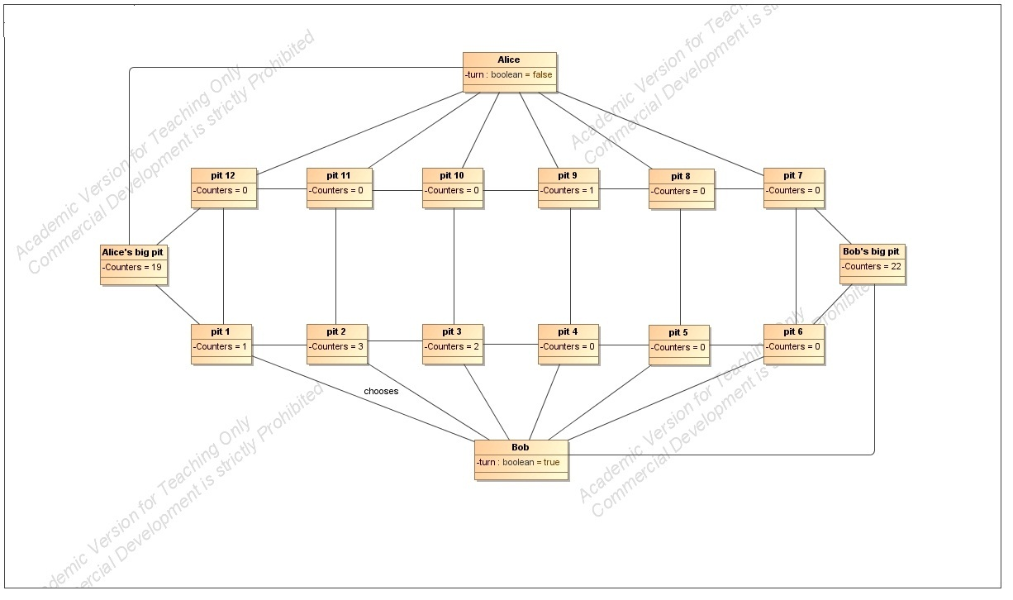

Postconditions: the pits on the board contain the following amount of counters: pit 1 – 0, pit

2 – 4, pit 3 – 2, pit 4 – 0, pit 5 – 0, pit 6 – 0, pit 7 – 0, pit 8 – 0, pit 9 – 1, pit 10 – 0, pit 11 – 0, pit 12– 0. There are 22 counters in Bob’s big pit and 19 counters in Alice’s big pit.

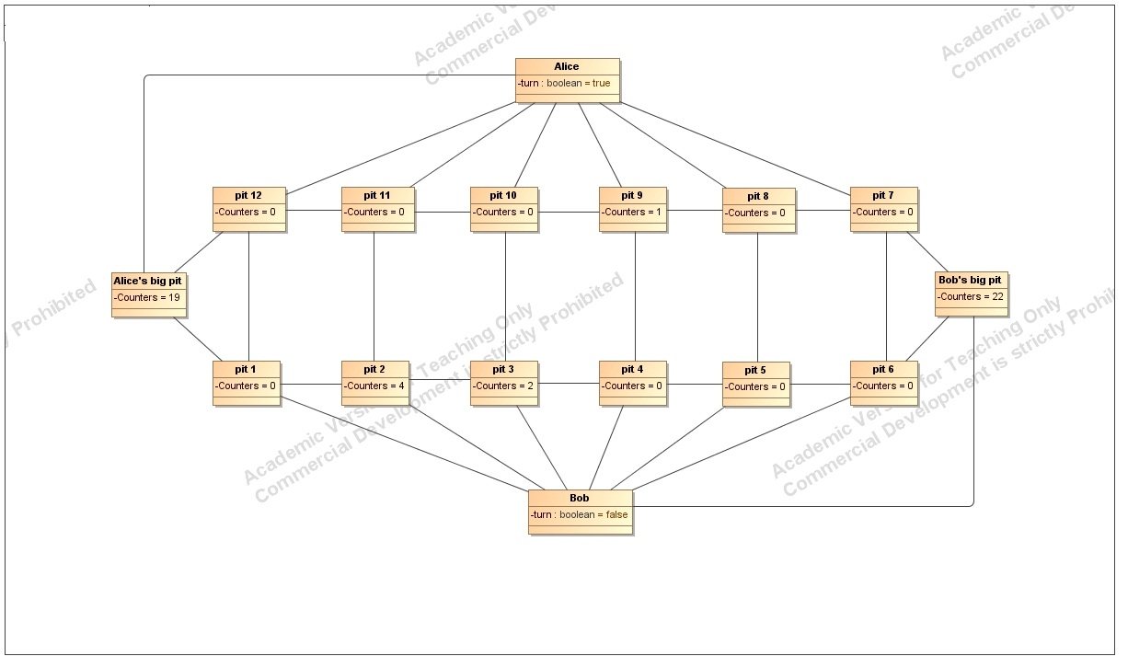

33.

Title: Alice makes a move from pit 9

Preconditions: the pits on the board contain the following amount of counters: pit 1 – 0, pit

2 – 4, pit 3 – 2, pit 4 – 0, pit 5 – 0, pit 6 – 0, pit 7 – 0, pit 8 – 0, pit 9 – 1, pit 10 – 0, pit 11 – 0, pit 12– 0. There are 22 counters in Bob’s big pit and 19 counters in Alice’s big pit.

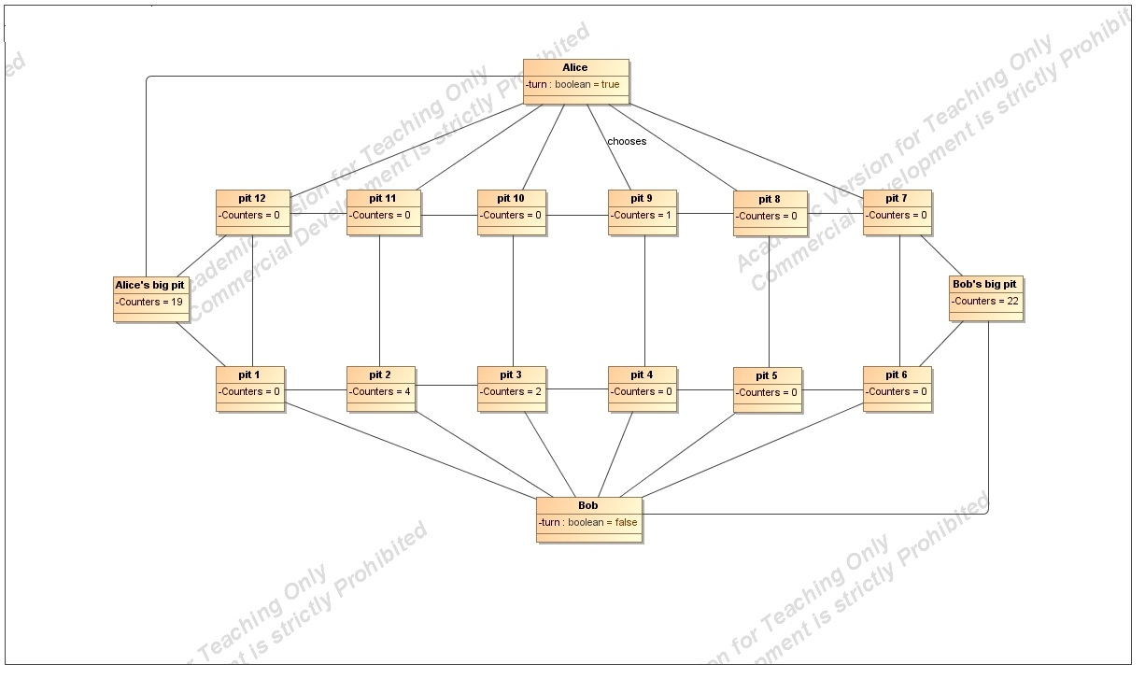

Postconditions: the pits on the board contain the following amount of counters: pit 1 – 0, pit

2 – 0, pit 3 – 0, pit 4 – 0, pit 5 – 0, pit 6 – 0, pit 7 – 0, pit 8 – 0, pit 9 – 0, pit 10 – 0, pit 11 – 0, pit 12– 0. There are 22 counters in Bob’s big pit and 22 counters in Alice’s big pit. 4 remained counters will be added to Bob’s big pit. Bob has won the game with 26 counters against Alice’s 22 counters.

